https://www.dropbox.com/s/xyjiv1q39w3lmmr/April_June_2014.docx

ORA Bulgaria Report
April – June 2014

- Relief work

ORA Holland sent a truck in December 2013 with second hand cloths, food, building materials, chairs, shoes, medical equipment and many other things for the poor and needy people in Bulgaria. January-March was the period of almost 90% distribution of the goods. We left some of them for crises situations. In April-June period we distributed the rest of the goods to the most needy people including the refugees in the refugee camp in the city of Harmanly, next to the Turkish border. In the end of June we visited the refugees together with Erik Merx, ORA Holland director and we took food for the refugees in the camp – children’s food, vegetable soup, tea, candies. Families with children were so thankful for the help in that difficult for them situation. One Kurdish family with 6 children just arrived from Irak a week ago. One of their children, 9 year old boy was paralyzed a week after he was born. He was in a so bad condition that he could not even seat or walk.

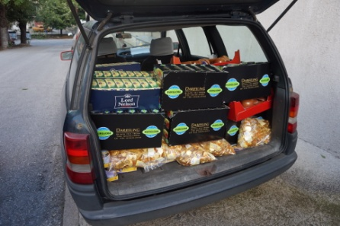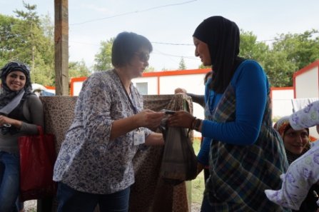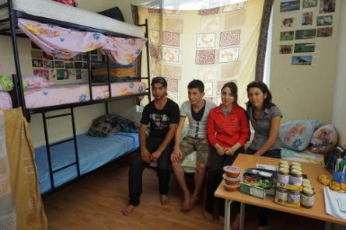

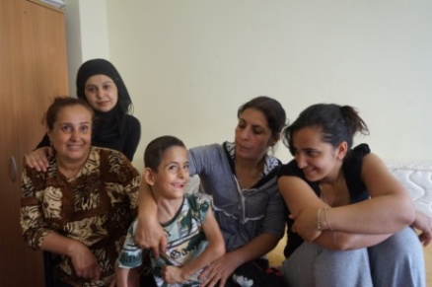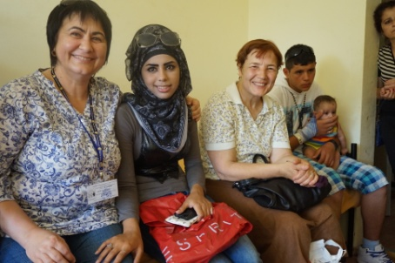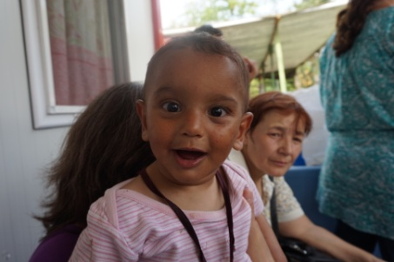

- Zelenikovo, Brezovo and Karlovo Orphanages
Zelenikovo and Brezovo children were very happy seeing us in a monthly base, in April-June period. ORA volunteers (most of them present OMTC students) visited them and we all had great time with the kids and the staff working there. We spend our time with them playing different logical games and discussing different issues about building relationships, good manners of behavior and some other things that are helpful for their age.
There are 7 children in the orphanage in Karlovo who are from a mother who was living at the same orphanage before she became 19 years old. She married and divorced several times and she could not take care of her kids and she left them in the orphanage. For three years they were together at the same orphanage in Karlovo but later on three of them were separated in two different orphanages. Older children stayed in Karlovo but the younger were sent to the orphanage in Zelenikovo. For two years they could not see each other and they missed each other very much. ORA volunteers visited them regularly in both orphanages, Karlovo and Zelenikovo, taking photos and helping them to contact through internet – video on Skype and phone calls. In the beginning of April, during Spring vacation, ORA volunteers organized a visit of the older children from Karlovo orphanage to the younger children in the Zelenikovo. We covered the expenses for the traveling and the lunch they had together during their reunion. It was wonderful time of joy and sharing between brothers and sisters from one family.
Visiting orphans often is our way for building close relationships with them and helping them to be integrated in the society.

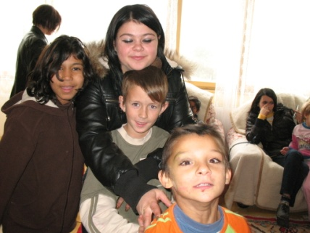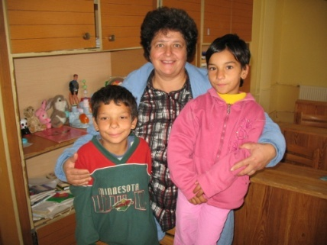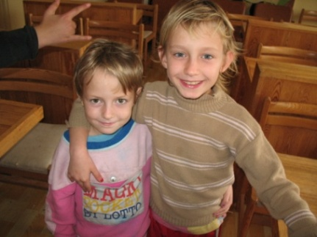

- Syrian Refugees in Bulgaria

Syrian war forced millions of people to leave Syria. More than 10 000 refugees came illegally to Bulgaria through Turkey just during 2013. Another 1600 refuges came illegally just during January and February. Through the help of EU Bulgarian government overcome the difficulties and now the situation in the refugee camps is much better than in the end of 2013. There are no any refugees living in tents anymore. Situation is getting better but still many things are needed to be done for those people.
Bulgarian church is challenged now for reaching the refugees in Bulgaria with the Gospel. A Sunday afternoon service is already taking place at the camp in Harmanly for refugees from different African countries (Gana) and few Syrian Christians. OMTC students and ORA volunteers visited the camp in Harmanly in the end of March and took part of the service. The most exciting time was the fellowship with Syrian refugees outside of their places for living. More than three hours we spent with them talking and sharing Jesus with them. One Syrian man was sick and we took him to the hospital. After he was checked by the doctor we bought the medicines prescribed to him by the doctor and we took him back to the camp. His refugee neighbours were amazed to see Bulgarian Christians helping to a Muslim Syrian man and even buying him medicines. That was a very good testimony for our Lord Jesus Christ.
Children and their parents still remembered us from Christmas time 2013 when we distributed 500 Christmas boxes to them and were very thankful.
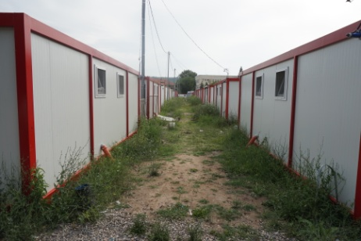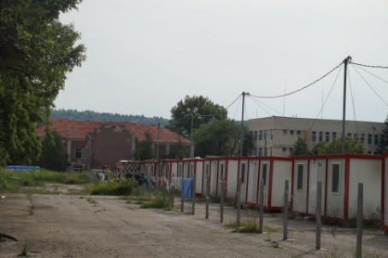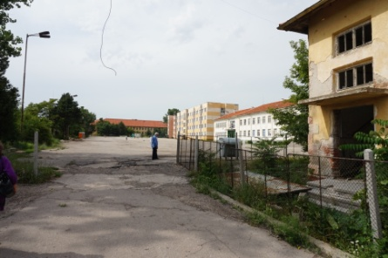

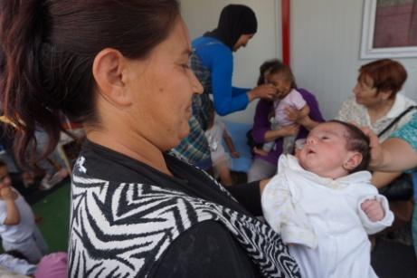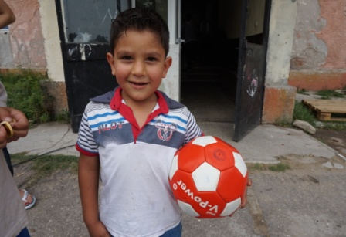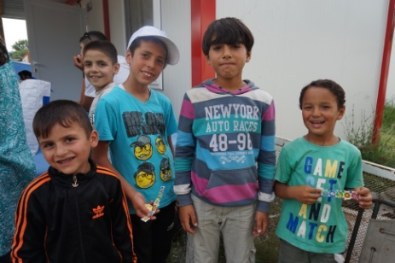

- OMTC school year 2013-2014
OMTC school year finished on June 15 2014. Graduationsof the students took place in several places – Pleven, Kirchevo,Lukovit, Plovdiv, Varbitsa, Boliartsy.
Plovdiv – 14
Boliartsy – 6
Varbitsa – 14
Pleven – 5
Gornik – 7
Radomirtsy – 4
Lukovit – 4
Kirchevo - 6
----------------------------
60 students in 9 schools
There are 4 schools with two year program with 48 students who are going to graduate in June 2015.
After the graduations the internship for those students who graduated is going to take place for four weeks. Students are going to help churches, evangelize people in Rodoppa Mountains where Turkish and Pomak people are living. They will show Jesus and Magdalena films in villages, distribute brochures, booklets, New Testaments, and other Christian literature.
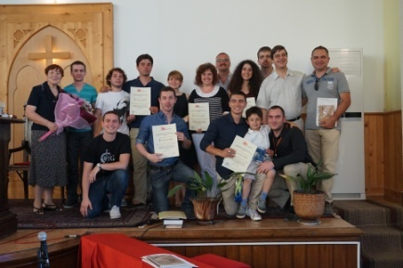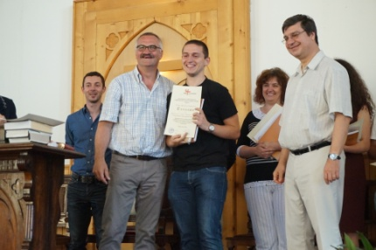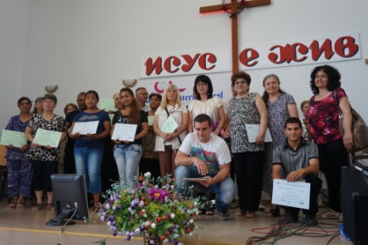

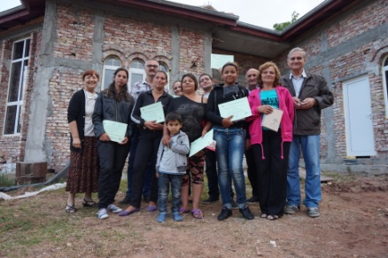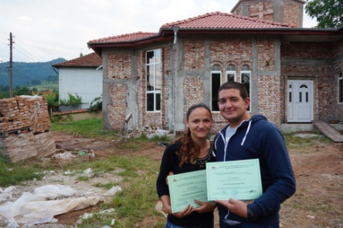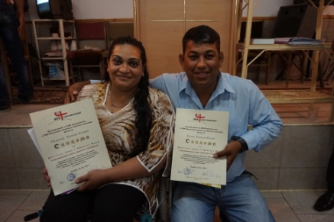

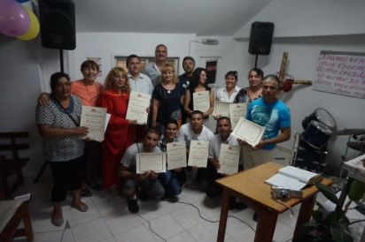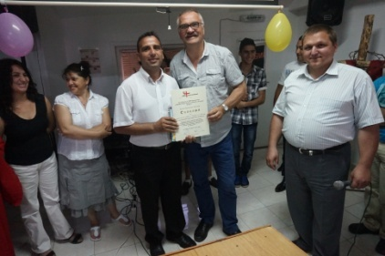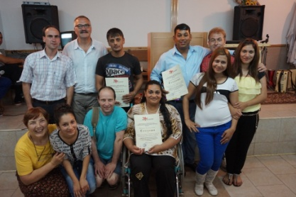

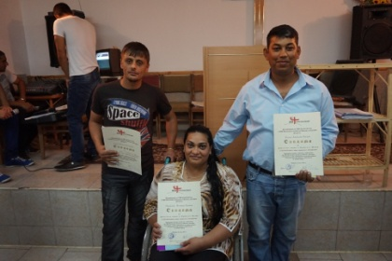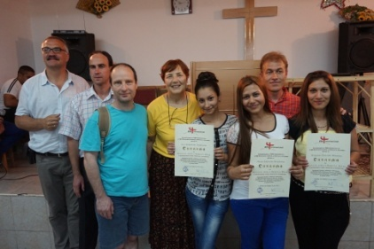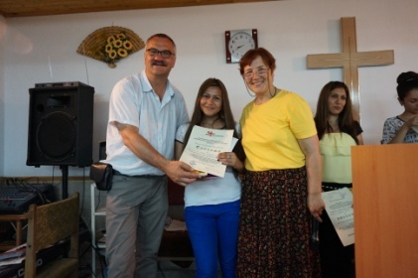

- Foster Families
ORA Bulgaria volunteers, Amanda and Gayton Liter were a couple who promoted Foster Family Care for children and adoption of orphans. The good news is that they personally became the best example to follow through the adoption of twins – two boys of 4 months old who were bended by their biological mother. Now The Liters are proud parents of those two precious children, Andrew and Elei. Another good result from our work in that area is that an 39 year old lady decided to adopt a child after participating at our seminars on Foster Family Care. She is approved by Bulgarian Social Agency for adoption and soon she will become a mother.
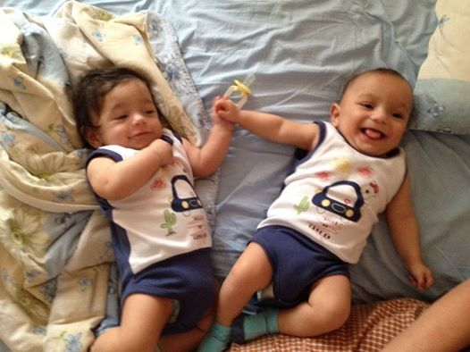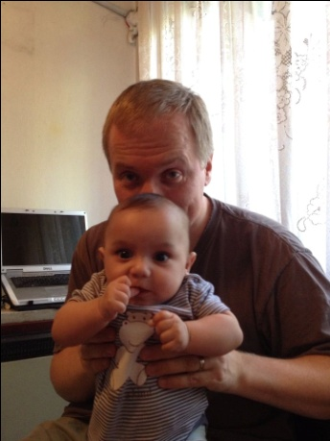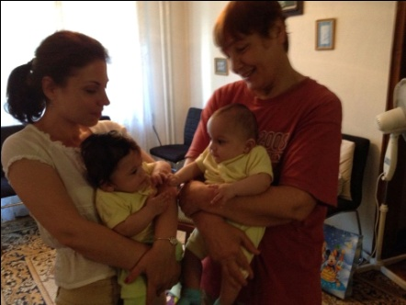

- Human Trafficking
Work with human trafficking is very intensive! Our focus right now is prevention work because it is a great toll for minimizing the number of the victims from Bulgaria. Informing young people, girls, boys and young women for the human traffic and sexual exploitation, helping them to be more careful when they look for jobs in Western countries and advising them what to be cautious, and ways to check their future working place, employer and many other things helpful them to be aware of.

In April we had a presentation of Human Traffic in the orphanage in the city of Bracigovo with about 60 young people, boys and girls, who are 80% from Gipsy background. We distributed brochures and presented a film on that topic.
In May our team presented the materials for prevention to the woman’s leaders from different denominations in a short seminar with 10 ladies who were willing to present the materials to their churches and organize seminars on that topic for their people and especially to Gipsy people who are the target group for modern slavery.

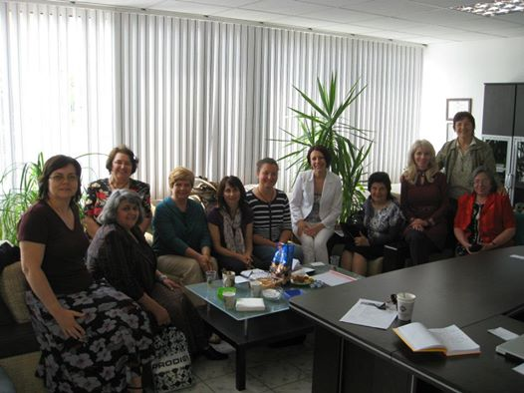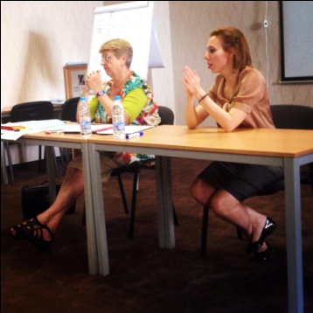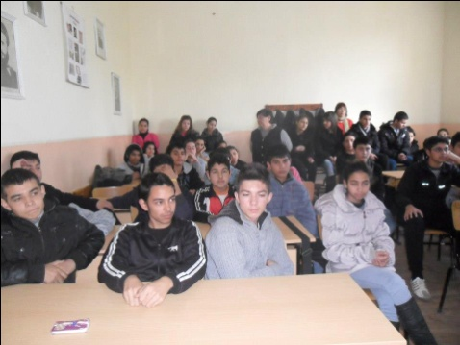

- Future Plans for July - September 2014

We continue working with the orphanages, trafficking, Syrian refugees and OMTC.

Training OMTC students is our obligation and a privilege to be part of fulfilling God’s Great Commission. We plan starting new OMTCs on October 1th 2014 in Sofia, Bracigovo, Svoboda, Shumen, Tzarevo, Russe and continue with the second year of those which already have. In that way more people will be trained to serve God, knowing Him better and making Him known to others through obeying God’s Great Commission to make disciples from all nations.

We plan to expand the work in anti trafficking work among the most vulnerable groups in Bulgaria – Gipsy people, orphans, young girls and women, poor people too. We are working on a new booklet on that topic for distributing to all those groups of people. The booklet will be printed in several thousand copies (depending on the finances we have). Our goal is to have seminars in different churches during the weekend and short presentations on trafficking with specific films on that topic.

We plan continuing the work with children in the orphanages in Zelenikovo, Karlovo, Narechensky Banie and the refugees in the Refugee Camp in the city of Karlovo.

We continue the work for promoting Foster Family and Adoption in the churches because we see good results – several families already are taking care of children as foster parents and tow already adopted children.
We would like to ask you to pray for us in order to be faithful servants!

