ORA BULGARIA ACTIVITY REPORT
October – December 2015

Situation in Bulgaria
Political and economic situation of Bulgaria is still bad. Government is not doing its best for fighting the corruption and mafia. The country is still the poorest one in EU with a minimal salary 215 EUR per month or 1.28 EUR per an hour. The minimum pension for retired people is 80 EUR per month. People are without any hope that the change would happened. Refugees are still crossing illegally the border with Turkey and Greece although their number is not big as it was in 2015. Both groups of people, Bulgarians and refugees need help in order to survive.
Here is the work of ORA Bulgaria for the first quarter of 2016:

- Zelenikovo, Brezovo and Karlovo Orphanages
We continue visiting orphans in Karlovo, Zelenikovo and Brezovo every other month. During the first three months of 2016 our visit of the orphans was in the end of February. ORA volunteers spent three hours with children each time, as it was allowed for us by the staff there. ORA volunteers were playing different games with children and sharing different stories. We are always welcomed there because we help orphans in their needs and integration into the society. This time we gave them tooth paste and brushes, pens and also bananas.
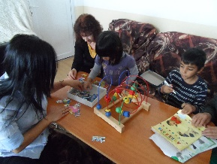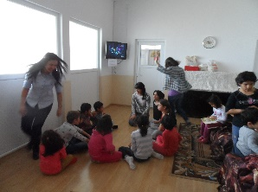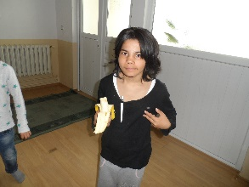

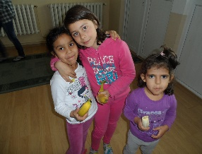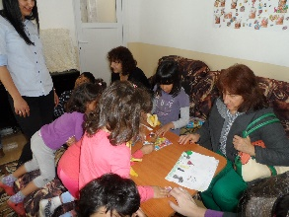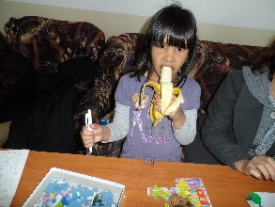

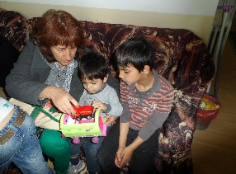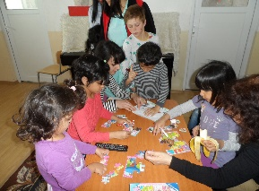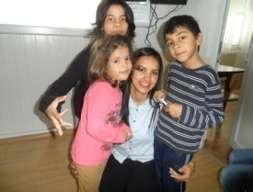

- Humanitarian help

In the beginning of December we received two pallets with goods from ORA Holland. We downloaded the two pallets and put them in the storage. Bigger part of the goods were distributed in December 2015 but the other part, especially the seeds were distributed in February-March of 2016. Most of the goods were given away to Turkish villages in Sothern part of the country where people were forgotten by the Government and politics.
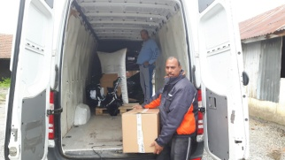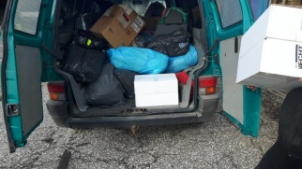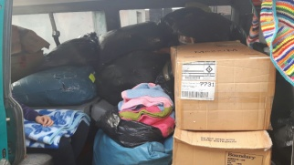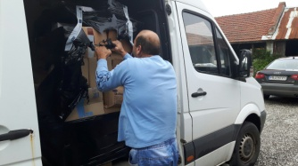

- Refugees in Bulgaria

Harmanly refugee camp has just 150 refugees during the first three months of 2016.
ORA volunteers and OMTC graduates from the church in Haskovo, including their pastor Vesko Jotov (OMTC graduates) are helping refuges regularly with warm clothes, food, mattresses and hygienic-sanitarian materials that were supplied by ORA Holland in December 2015.
Zahra Shahsavani, a refugee girl from Iran, came to Bulgaria through Turkey. While in a refugee camp she took her most important decision in her life to follow Jesus. She found wonderful Christian friends and she decided to stay in Bulgaria. Now she lives in Nesseber, at Black See, working in a beauty shop and she is a part of local Pentecostal church there. What an amazing story for the love of God.

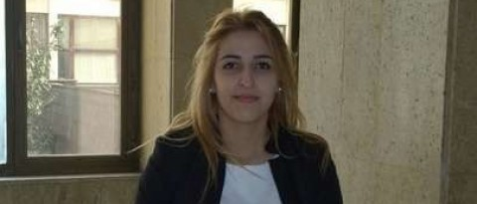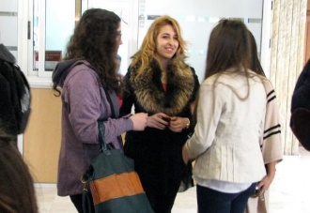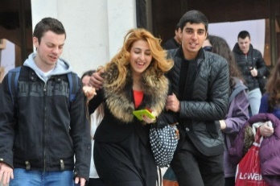
Zahra Zahra and her Bulgarian Christian Frinds

- OMTC school year 2015-2016

New OMTC year started in the beginning of October and November in 8 places – Plovdiv, Pleven, Shumen, Karlovo, Simitly, Svoboda, Polsky Trambesh and Kardjaly. Some of the training continues for second year – Shumen, Svoboda, Simitly, and Polsky Trambesh but for Plovdiv, Pleven, Karlovo and Kardjaly it is for one year training.
There are 78 students on the list for training for 2015-2016.
There are problems with OMTC in Polsky Trambesh and OMTC in Svoboda. Most of the students went to work outside of Bulgaria due to the bad economic situation in our country and high % of unemployment. OMTC Polsky Trambesh stopped classes just after Christmas because there were no students left on that same reason. OMTC Svoboda continued classes with just few students because most of the girls’ students from Gipsy background got married and left the village with their husbands.

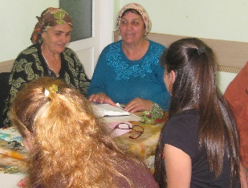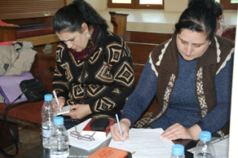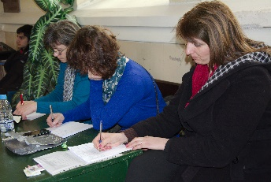
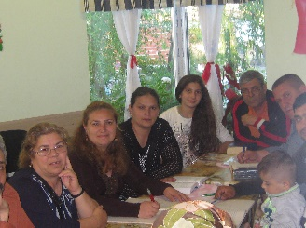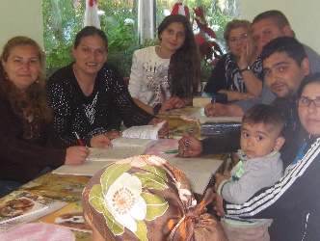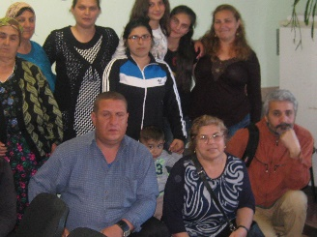
Turkish speaking students in Kardyaly OMTC

Kairos Course
ORA Bulgaria is involved in organizing Kairos courses in Bulgarian churches as partner with PAOB – Pentecostal Assemblies of Bulgaria. OMTC Bulgaria included Kairos course in their training. It is a course for motivating believers and churches for Missions. In January Kairos was done in Plovdiv and present OMTC students and former OMTC students took part of Kairos training. There were 41 participants and they all were so excited to see God’s heart for the un reached peoples (URPG) groups on the Earth. They had special cross cultural experiences during the training and those events changed their lives totally. Some of the former students are already trained to be facilitators for Kairos course and their goal is to have trainings though the whole country.
Rossen Spiridonov said: Kairos course was as a contuniation of my study in OMTC. I am so touched by God’s plan for reaching all ethnic groups in the world.
Lubomir Chernev: I grew up in a Christian family and I thought I knew all from the Bible. Kairos course helped me to realized I the opposite. Now my heart is biting with God’s heart for the un reached peoples groups. God’s plan for URPG is amazing!
Teodora Bashova: I am OMTC student this year and I have never had any cross cultural experiences. I was shocked to understand I was not prepared to meet and serve people from URPG. I learned so many new things for God and His heart for URPG.
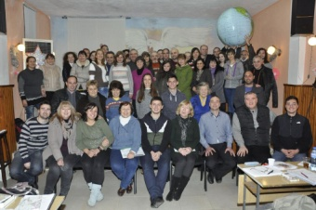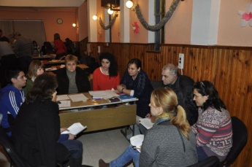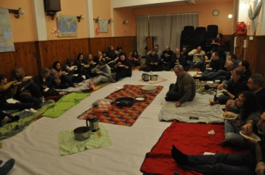

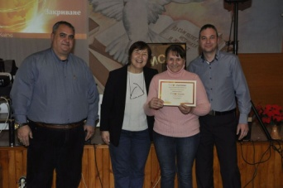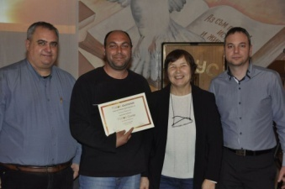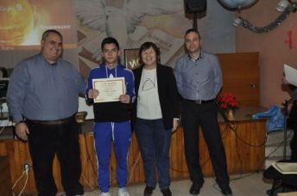

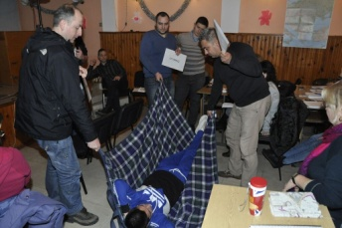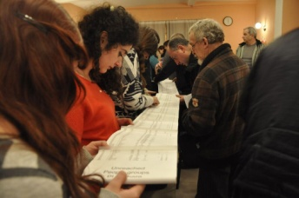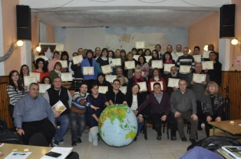
- Human Trafficking
We continue our work in Human Traffic. Our main focus is on prevention because it is a great tool for minimizing the number of the victims from Bulgaria sent to Western Europe. We did two seminars during the first quarter of 2016. First one was with women at Woman’s conference on March 19th in Plovdiv where Marina did the presentation with some ORA volunteers. The second seminar was in a public high school of Rakovsky city. We were promoting the new hot telephone line for HT victims: 0800 20 100. Students and women were so touched by the information presented there.
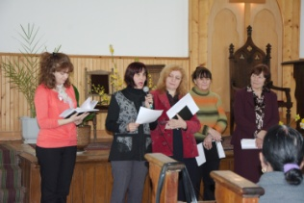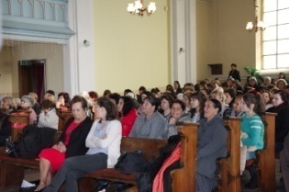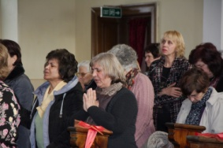
Woman’s conference – Plovdiv – women praying for HT victims

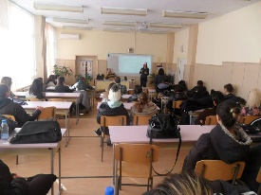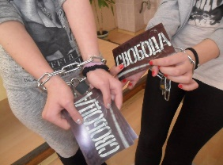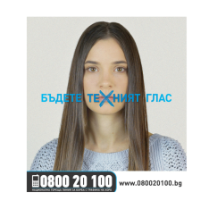
HT presentation in a public school in the city of Rakovsky

- Future Plans for January-March 2016

We continue working with trafficking, Syrian refugees, orphanages, and OMTC.

Training OMTC students is our obligation and a privilege to be part of fulfilling God’s Great Commission. We plan training in some new places, especially among Turkish speaking Christians and Gipsy churches.
We continue to have events for presenting prevention anti trafficking work among the most vulnerable groups in Bulgaria – Gipsy people, orphans, young girls and women, poor people. Our goal is also to have seminars in different churches during the weekends and short presentations on trafficking with specific films on that topic.

We plan continuing the work with children in the orphanages in Zelenikovo, Karlovo, Brezovo and help them to gain good manners and habits for contacting with people outside of the orphanages.

Refugees in the Refugee Camp the city of Harmanly also need our help and we plan to do our best to show God’s love and care, taking them food, cloths, sanitarian and hygienic materials, milk powder for the children and other needy things.

We would like to ask you to pray for us in order to be faithful servants and fulfill what we have planed! Please, pray for the Turkish OMTC in Kardjaly in order to be good and brave witnesses for the Turkish people there. Thank you!

