LOGOS Global Vision - BULGARIA ACTIVITY REPORT

July – September 2017

Situation in Bulgaria
During the summer the situation in Bulgaria was quite intensive. The Parliament could not reach a consensus in passing the Law for juridical reforms and the Law against corruption. It created social tension in the society and many people protested on the streets and squares. Economy of the country is not developing intensively and Bulgaria continues to be considered as the poorest country in EU. Bulgarians are hopeless and desperate in their own country. In order to have better life they leave the country and go to different EU countries for working and living there.
One of the biggest problems in the country is non successful integration of Gipsy population which is 4.9% . Most of Gipsies are not educated, they do not encourage their children to go to school and this the reason for very high an employment among them. Most of the crimes in Bulgaria are done by Gipsies and prisons are full of them. At the same time a quite big number of Gipsies are involved in Human Trafficking, selling their girls in prostitution in Western countries.
Another problem is refugees who are crossing the border with Turkey illegally. Most of them want to go to Western Europe and do not want to stay in Bulgaria because Bulgarian government do not offer them good social care and insurances neither enough financial support to live in the country. Although thousands of refugees are leaving to Western Europe through Bulgaria, there are many who stay in our country. They are in refugee camps in different places. LOGOS Global Vision - Bulgaria is working with the refugee camp in Harmanly city, 100 km south of Plovdiv and 35 km from Turkish border.

- Zelenikovo, Brezovo and Karlovo Orphanages
During the third quarter of 2017 we visited orphans in Karlovo, Zelenikovo and Brezovo just once for each orphanage, in September. The reason for just one visit was the summer season when children were taken to different activities outside of the orphanages. LOGOS Global Vision volunteers spent two hours with children, as it was allowed for us by the staff there. We were playing different games and sports with the children and having discussions on different topic they were interested. One of the volunteers helped them make a poster with their hands on it. Children drew their hands and painted them with different colors. Poster became wonderful colorful art work and children put on the wall of their main hall.
All children received school materials for the new school year started on 15th September. We gave them also some chocolate bars, coocies, bonbons, croasants, etc.
Here are some thoughts from the children:
Albena (10) said “You are coming regularly to visit us and spend time with us. I like that you stay two hours with us and talk to us, bring inresting topics of discussion, help us to communicate with people outside of the orphanage. Many people come and visit us but they just drope the material things they bring for us and immideatly leave. You are different! You love us! Thank you”!
Marijan (9) “I like you very! You alwayes talk to me and you encourage me to study harder in school in order to have better life in the future. You even checked my homowork. Nobody has done that! And you always bring me something I like to eat, a candy!”
Vassil (12) “Thank you for coming so regularly to visit us very month. You motivate us to have dreems for our future and to dreem big! I did not have any courage for my life before I met you. Your visits here changed my selfesteem and now I have hope for my life!”
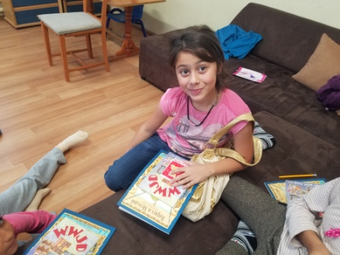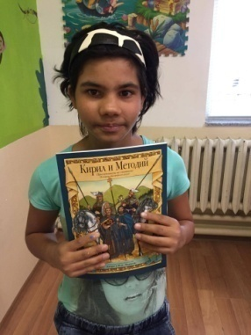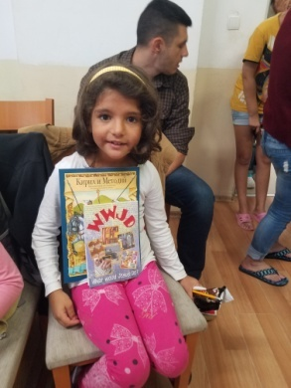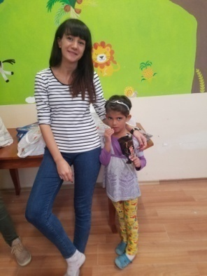

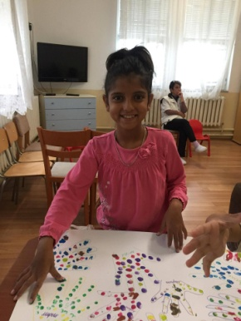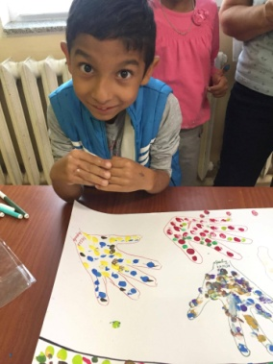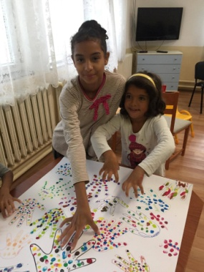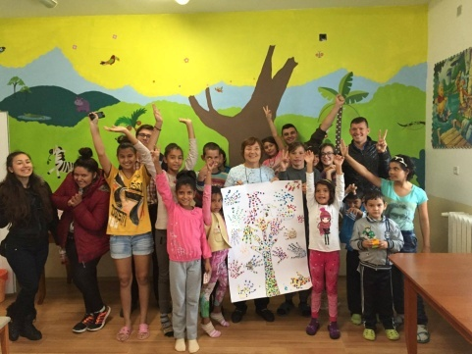

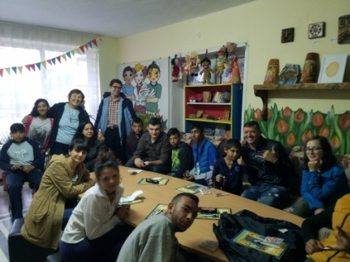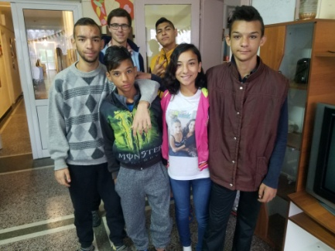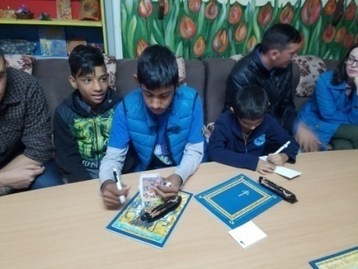

- Refugees in Bulgaria

During the summer the number of refugees in Harmanly refugee camp was reduced to 600 people because refugees took advantage of the warm weather to cross the country and travel to Western European countries. At the same time the number of those who crossed the border illegally increased dramatically and refugees were paying a lot of money to the traficants in order to go out of the country and reach their destination.
LOGOS volunteers who are former graduates from the Bible school in the church of Haskovo city, including their pastor Vesko Jotov (also graduates) are helping refuges regularly with clothes, food, baby milk, dippers, and hygienic-sanitarian materials. At the same time they supply spiritual care for the Christian refugees and share the good news with Muslim refugees. We need people who know their languages (Fercie ) and also volunteers to teach them Bulgarian language and help them to integrate fast in our society.
Please, pray for peaceful and effective work and ministry among refugees in Bulgaria!
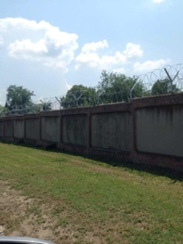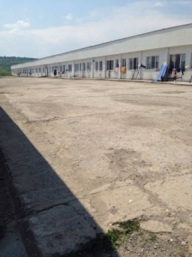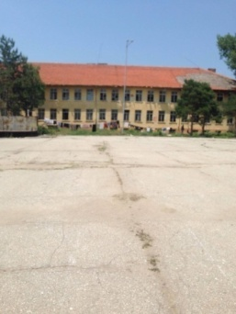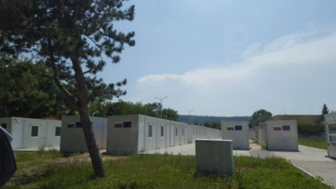

- Summer Youth Camp for Studying the Bible Inductively

Youth camp for studying the Bible was organized for three days, 7-8 of July, 2017. The seminar was for children from 8 to 15 year of age. The goal was for evangelizing the children through studying the Bible and helping them to find the truth for their salvation by themselves.
The kids were from Gipsy churches in the village of Maglizh. They studded the book “Jonah”. Eight children from non Christian families participated at the seminar and they prayed and asked Jesus to be their personal Savior and Lord at the end of the camp.
During the breaks there were different games and surprises together with food and drinks. After classes the kids were given homework to do at home. Their mothers and fathers were so surprised when they brought them the following morning, saying: “We could not recognize our kids. They came back home after studying the book during the day and immediately went to do their homework. They were so busy and occupied that even did not watch TV or do anything else but study and prepare their homework. We have not seen them so interested in studying the Bible!” The children liked the study very much and asked for another book to be studied next vacation.

All kids received snacks, drinks, and small gifts
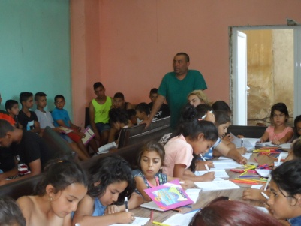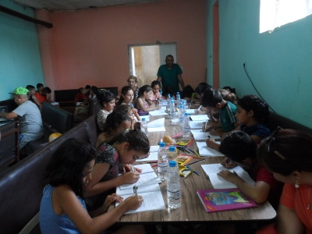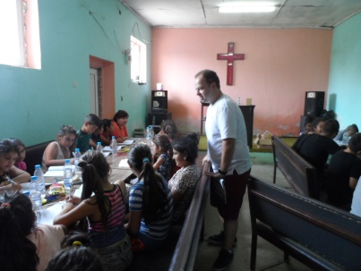

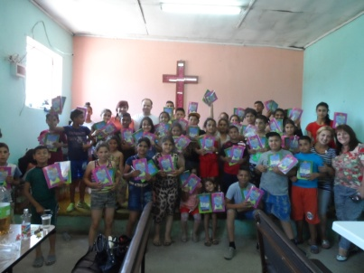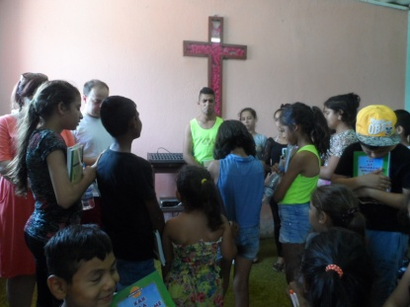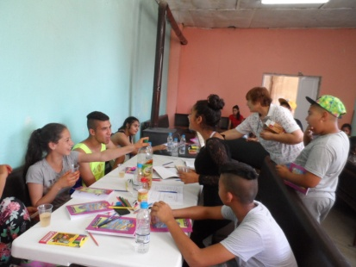
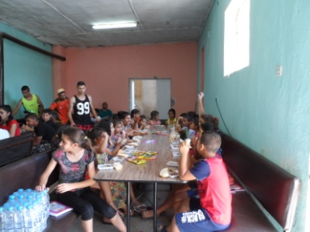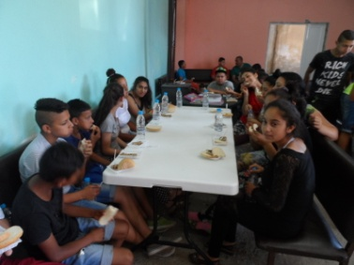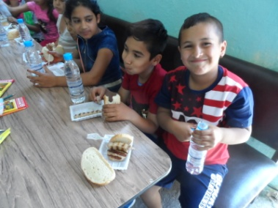
- LOGOS Bible School

After graduations in June 2017, students had one month internship for practicing what they already learned at Logos Bible schools.

Students traveled to different places in Bulgaria preaching the gospel, distributing humanitarian goods to the needy and poor people, giving away Chrsitian literature and brochures, sharing their personal testimonies and many other things that were needed to be done.

Students from Plovdiv Logos Bible school went to Rodoppa mountains, visiting and helping the missionaries among the Muslims. It was such a great experience for them to pray for the people there and share the love of Jesus with Muslim people on the streets, to encourage the new believers from Muslim background in house churches and to preach the gospel. They learned a lot on the mission field and saw the difference between theory and practice. They all came back home blessed and full of jalousie for God and willing to serve Him faithfully.

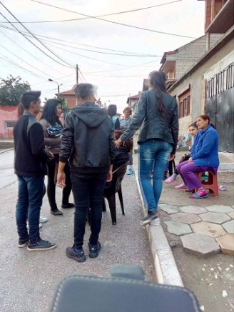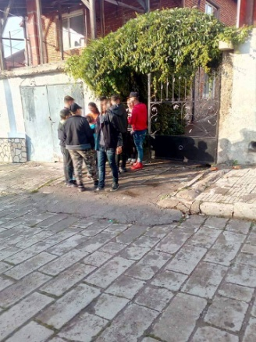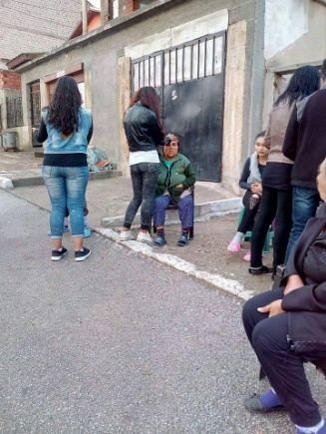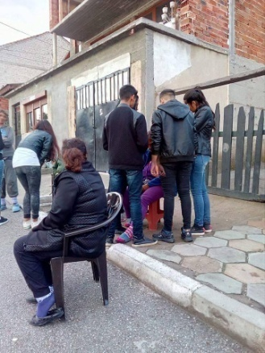

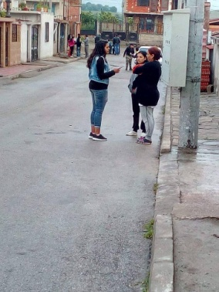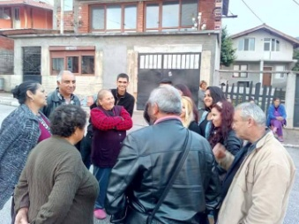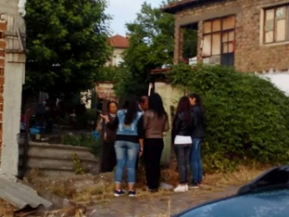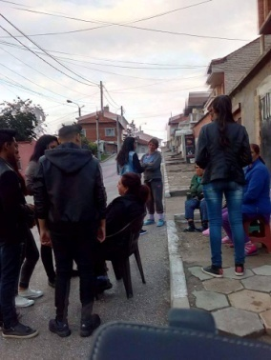

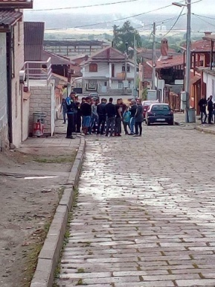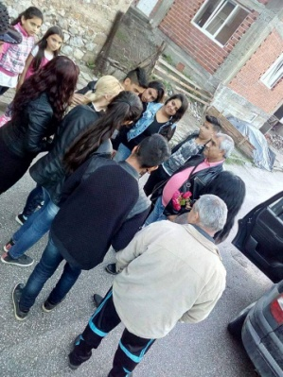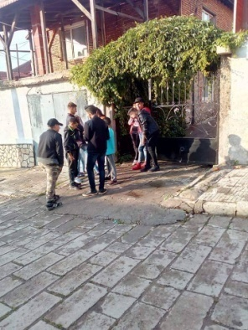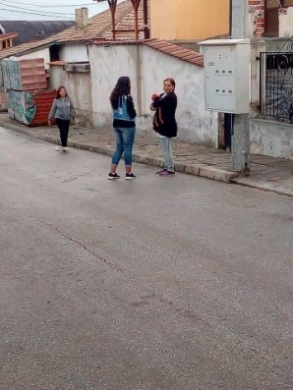

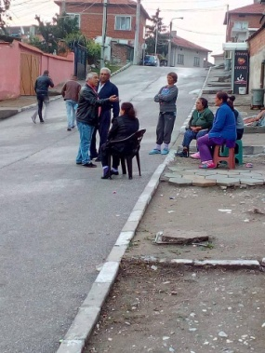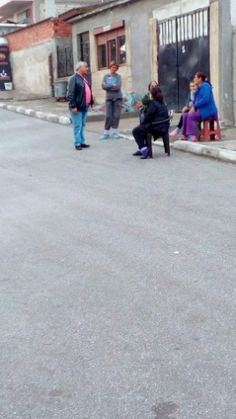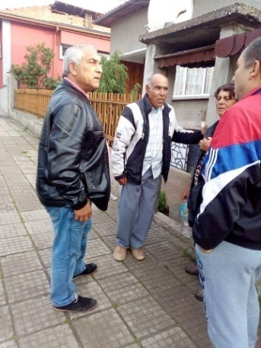

- Kairos course

Logos Bible school in Bulgaria is involved in organizing Kairos courses in Bulgarian churches as partner with PAOB – Pentecostal Assemblies of Bulgaria. Kairos course is included now in the training program of Logos Bible school. It is a course for motivating believers and churches for Missions. Kairos course was done in July in Karlovo, where Logos Bible school students from previous years were participants. Through Kairos course participants could understand God’s heart for Less Reached People Groups and His plan for reaching them. There were three parts of the course – Biblical, Historical, Strategic and also Cross Cultural Experiences. Change could be seen in the participants while the course was going on. All participants were so touched and motivated to do Missions and they learned that Missions is done by hands that give, knees that pray and feet that go.

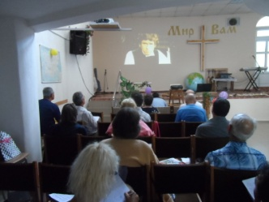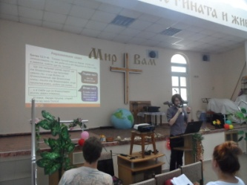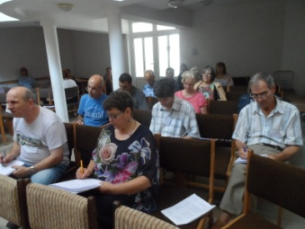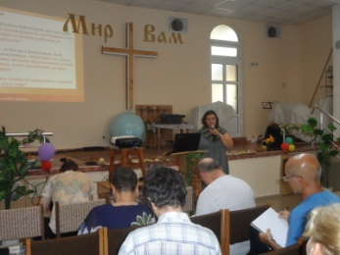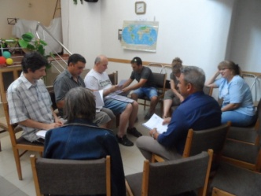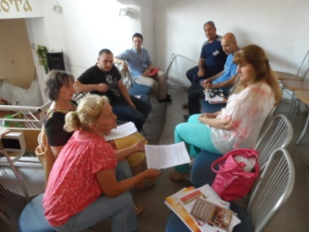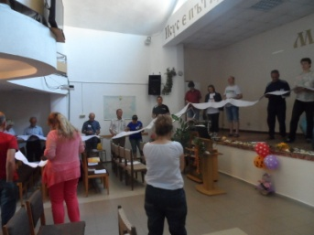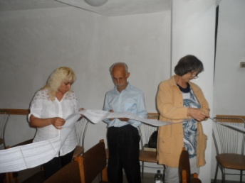

- Human Traffic – Prevention
We continue our work in Human Traffic, so called “modern slavery”. Our main focus is on prevention because it is a great tool for minimizing the number of the victims from Bulgaria sent to Western Europe. We did one seminar in Tzalapitsa village, 16 km from Plovdov, in a Gipsy church. Gypsy adults shared that strangers were going through their quarter with big Jeeps and kidnapped some girls who never came back. The problem was that the parents of those girls were working abroad and grandparents took care of them but it was not sufficient for the safety of the girls.
We gathered Gypsy people, especially young ones and gave them rich information about the ways of protecting themselves from bad people with bad intentions, whose goal was to kidnap girls and take them abroad for prostitutes. We distributed stickers with hot telephone line for HT victims: 0800 20 100. We show a movie for real cases of young girls in prostitution who were kidnapped or lied for a good job abroad and were forced in prostitution. We also distributed brochures, booklets and other
materials.
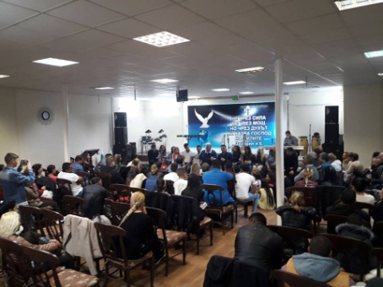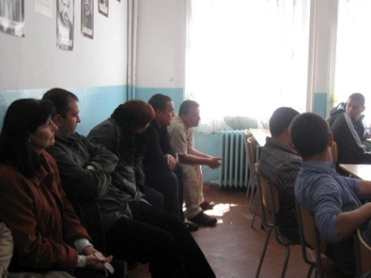

Future Plans
- Opening new school year for the bible schools. We are so excited for the new name of LOGOS Bible school. We continue the school in Plovdiv, Biala Slatina, Krushovitsa, Pomorie, Pleven. – 4 schools started last year. At the same time we are planning to start new schools in Sliven and Saedinenie and we are in a process of organizing them.
- Collecting finances for Christmas gifts for the orphans from Karlovo, Brezovo and Zelenikovo.
- Prevention work in HT for the children in the orphanages in Brezovo, Karlovo and Zelenikovo.
- Visiting Harmanly refugee camp and helping the refugees with physical and spiritual help.
- Two Kairos courses – One in Sliven city in October and the other one in Pleven city in November.
Please, pray for us to be instruments for fulfilling all those activities for God’s glory and blessing the children, refugees, Gipsy children and communities, churches in Bulgaria and Bulgarian nation! Thank you in advance!

