LOGOS Global Vision - BULGARIA ACTIVITY REPORT

January– March 2018

Situation in Bulgaria
From the beginning of the new 2018 Bulgarian government has already taken over the leadership of EU for 6 months in a rotation principle after Latvia followed by Austria from July 1th.Bulgarian Prime Minister tries to raise the issue for Balkan countries as one of the important problems for EU. A visit by Russiaon Orthodox Patriarch on the National Day of Independence, March 3d, created a big pressure between Bulgaria and Russia. He tried to accuse Bulgarians for not being enough thankful to Russia for delivering us from Ottoman Empire back in 1878. Unfortunately, former Communists tried to defend him and that created great tension between different groups of Bulgarian society.
Corruption and crime are still big problems in Bulgaria and Government has not done its best for resolving those problems. Two very dangerous criminals succeeded to escape from Sofia prison, and are still not found. Cooperation for money of prison guards is one of the reasons for their escape, confirming the high level of corruption.
People are nervous because Government is not fulfilling the promised reforms and their financial situation is not getting better although we have been already 10 years in EU. People leave the country looking for jobs in Germany, Spain, England. A recent statistic says that the population of the country has dropped down and the most intelligent Bulgarians left the country and live and work abroad. That is one of the most important reasons for the country to stay in that difficult situation, the poorest country in EU. Prayer and works are needed!!!

- Zelenikovo, Brezovo and Karlovo Orphanages
- During the first quarter of 2018 we visited orphans in Karlovo, Zelenikovo and
Brezovo two times. Once in the beginning of January and the second time was in the end of February. As usual, LOGOS Global Vision volunteers spent two hours with children in each orphanage, as it was allowed for us by the staff there. Playing different games and sports indoor with the children and having discussions on different topics were part of our visits.
We bought nice winter pairs of shoes to each child in all four orphanages we visited. When children received them in a special nice boxes with their names of the boxes they were so happy and excited. Big smiles and many hugs were given away to the volunteers by them. Photos are a great evidence of that.
Here are some thoughts from the children:
- Albena (8) “Thank you so much for the worm winter shoes.! They are so nice! I can go to school without any problem now. Thank you for thinking of us!”
- Vanya (15) “Many people come to visit us and then go! You are different. You come so often and any time you come we have great time together. You brought us so many gifts last month for Christmas and here you are again with such a big gift for each one of us, brand new winter shoes. Thank you for your lovely care!”
- Marin (13) “Most of the people who come to visit us here in the orphanage bring us second hand cloths and shoes but not you. You lawayes bring us something new we need and like. Thank you for coming and bringning new winter shoes for us. Thank you!”
- Valentin (16) “Most of us here are disabled children. We need special care, special shoes. A month ago, Marina Dimitrova came and ask every one of us what kind of shoes we needed in order to be the most comfortable for us. She got the sizes of the shoes for each child! Today I can see that every one of us received very comfortabel brand new winter shoes as a gift from you! I thank you very much for your thoughthfulness!”
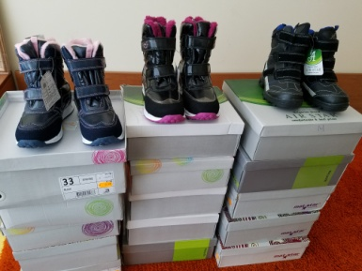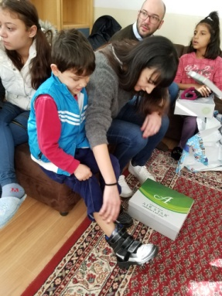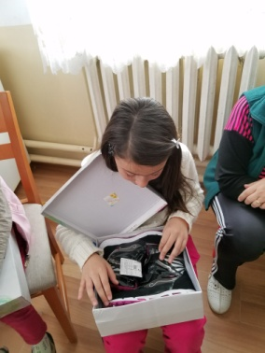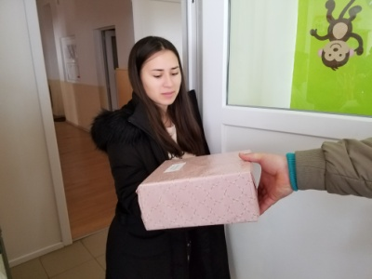
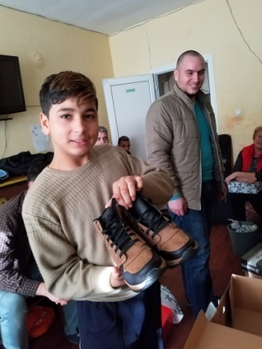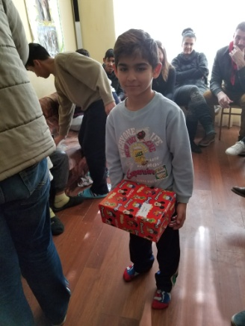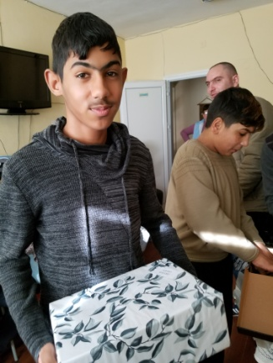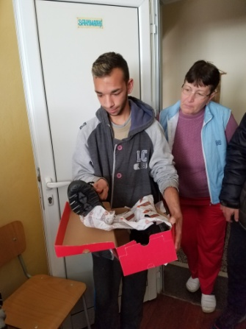

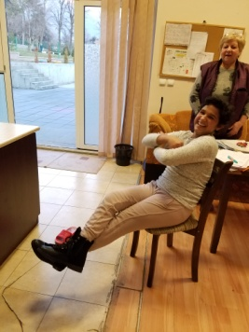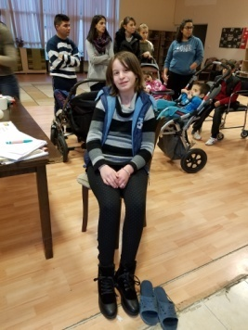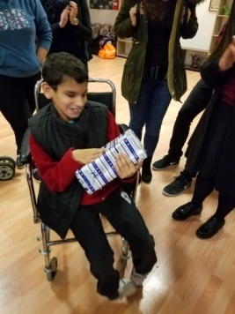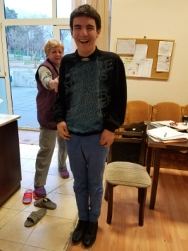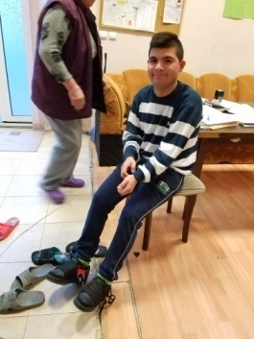
- Helping Bobie for his surgery
In the city of Karlovo there is a Center for 15 disabled children. Our volunteers started visiting and helping the children with different ways, few years ago. Mr.Adam Smith from England helps us with some finances to be more effective in our work with those children. Bobie is a 14 year boy with many helth problems. His right leg is not developed properly, it is crooked on almost 90 degrees and Bobie canlt walk but he uses will chair. His right hand is not developed in a proper way and he can’t use it. At the same time his left leg and left hand are not working 100% properly. British couple, Adam and Tara Smith who visited the orphanage and got familiar with Bobie’s health problem decided to help him. Three weeks ago I took Bobie to University hospital in Stara Zagora and the doctors decided to do several surgeries in order to help Bobie. First surgery is going to be done in April. Bobie is very excited about the new things happening to him and he is anctions to be more independent in his walk!

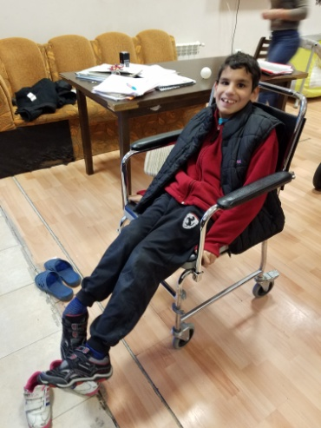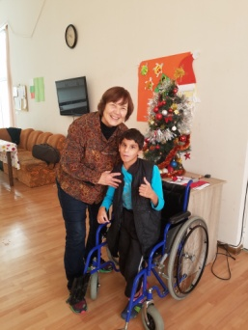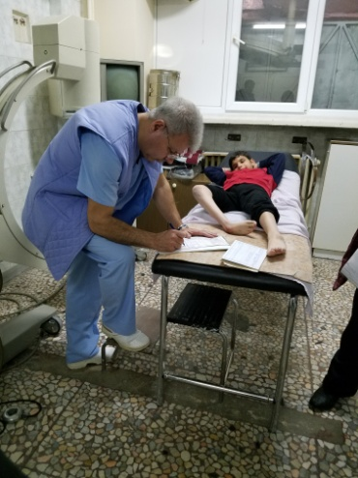

- Helping children from Zelenikovo orphanage to participate at Singin and Dancing Festival in Plovidv
There was a special festival for singing and dancing for children in Plovdiv. A group of children from Zelenikovo orphanage participates at that festival which was organzed on March 11, 2018. Logos global Vision - Bulgaria helped for transportation af those children in order to take part of the competition. Children presented three Bulgarian folk dances and they got the price for 1th place in that genre. Children were so happy and excited. After the festival we took them to the center of the city and we had wonderful time together showing them the hystorical parts of Plovdiv.

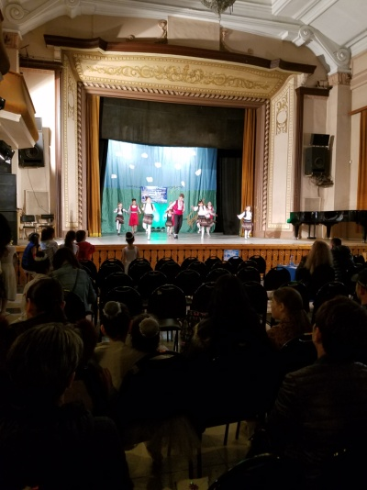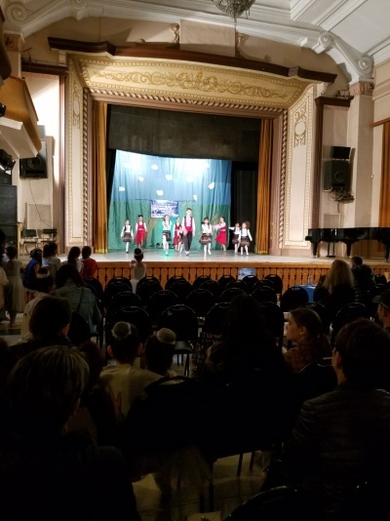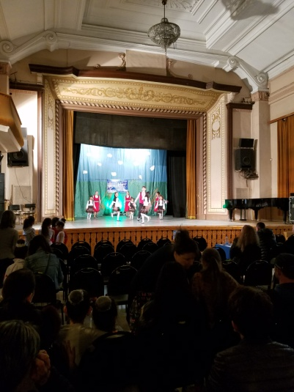
- Refugees in Bulgaria

During the winter the number of refugees in Harmanly refugee camp is not growing
Because the wall Bulgarian government built for preventing the illegal crossing the border with Turkey and also because of the agreement between Turkey and EU.
For those refugees who are in the camp in the city of Harmanly, LOGOS Global Vision – Bulgaria volunteers, who are former graduates from the Bible school in the church of Haskovo city, including their pastor Vesko Jotov (also graduates) continue helping them regularly with clothes, food, baby milk, dippers, and hygienic-sanitarian materials. At the same time they supply spiritual care for the Christian refugees and share the good news with Muslim refugees. They also help refugees who are Orthodox Christians from Syria, Iran and Iraq to be born again not just Christians by name or born in a Christian family. They teach them on forgiveness because almost most of them lost their family members in the war. It is wonderful to see the changes happening in their hearts and lives.

Logos Global Vision – Bulgaria volunteers bring hope for the refugees who would like to go to Germany where they can find better life for their families. The reason for that is that Bulgarian government only offers refugees poor quality housing for three months.

Please, pray for peaceful and effective work and ministry among refugees in Bulgaria!
No photos this time because the staff there did not allow taking photos due to some problems and tension between different groups of refugees in Harmanly camp.
Photos below are from previous times and they are posted here just to know get familiar with the situation at the camp.
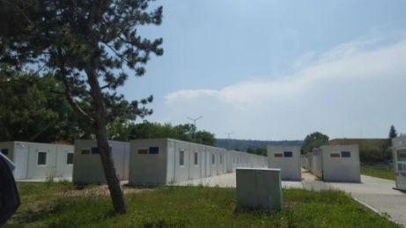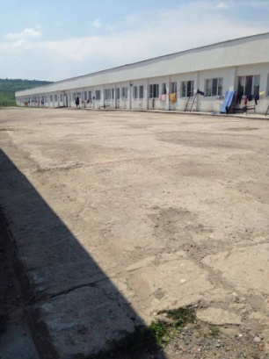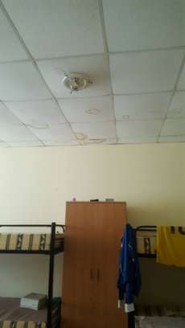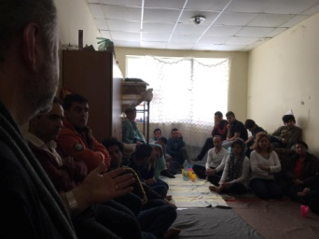

- LOGOS Bible School

Logos Bible School year started on 1th October 2017 and continues until the end of June. As I already wrote in the previous report (October-December 2017) there are less number of local schools and less students due to the transition period and changing the name of the organization from ORA International to LOGOS Global Vision. Students continue studying different topics as Studying the Bible, Relationships, Church and Ministry, Theology, Missions and Christian life. Graduations in all 4 schools this year will be in June for about 30 students:
- Plovdiv school - 5
- Pleven school – 4
- Krushovitsa – 6
- Pomorie school – 15
-----------------------------------

4 schools - 30 students

Students are from different ethnic groups – Bulgarians, Turks, Gipsies, but they study very diligently and would like to be better equiped for serving God and fullfiling His Great Commision. Here are some testimonies of the students:
  - Nelly Hristozkova from Plovdiv school – “I got my bachelor degree from Plovdiv University last year in June and in September I became a student of Logos Bible school. I wanted to study God’s Word and know His plan for my life. I grew up during the communism when teachers in public schools taught me there was no God. After the fall of communism religious freedom came to Bulgaria and I was able to hear the Good news. Soon after that I became a Chrsitian and I got married to an young man who already graduated from that bible school. He alwayes incouraged me to go to study the bible school and always tald me very good things about the school, the teachers, the program for training. The time for me to sudy is now because I neede to raise my son. I am almost three months in the school and I can see big difference in me. I got very good knowledge from the Bible and I got very good friends from my classmates. Teachers are wonderful Chrsitians and motivate us to become like Jesus, to serve Him for expanding God’s Kingdom in the world!”
  - Paisko Chakarov from Pomorie school (16)– “I was born in a Muslim family but I was not dedicated Muslim. When I was 11 year old I heard the Gosple from one od my classmates who was going to church. She invited me to her church and I went. On that same day I received Jesus Christ in my heart. Sonce then I have been part of church life but I alwayes wanted to learn more about the life of my Savior and to serve Him. That is the reason I became students of Logos Bibke school. During the school year I learned much more than I expected. Holy Spirit showed me God’s plan for my life and now I love God more than anything else on the earth. I want to serve Him for expanding His Kingdom in Bulgaria among Muslims.
  - My name is Pepa Mitkova and I am former Mulsim. As a little girl I prayed Muslim prays which I learned from my mother. In 1994 my grandparents became Christians and they tald me about Jesus Christ. I acceted His as my personal Savior and Lord. Later I got married to a Christian young man and now I have a wondeful Christian family. We have children who are also Christians and we all serve God. I am so happy to study at Logos Bible school because I learned many new things I did not know before. Teachers are very good and they teach us God’s Word and help us to understand God’s plan for salvation of all people from all ethnic groups. On eof the topics I like the most is Christian character. It helps me to know that I need to change my character, my way of thinking and acting. Yes, I get a lot of knowledge and a great chalange to become like Jesus!

- Kairos course

Logos Bible school in Bulgaria is involved in organizing Kairos courses in Bulgarian churches as partner with PAOB – Pentecostal Assemblies of Bulgaria. Kairos course is included now in the training program of Logos Bible school. It is a course for motivating believers and churches for Missions. Kairos course was done in February 2018 in Sofia Higher Theological School “St. Trivelij” for students who are getting their Bachelor and Master degrees. Fifteen students from 6 different churches were involved in Kairos training from several denominations. Cross cultural experiences were those who none of the participants had before. Here are some testimonies:
  - George (40) –“I have been a Christian for almost 20 years. My desire as a believer is to serve God in all ways it is possible. I like to study more in order to be effective in my ministry. Kairos course helped me to become “world Christian” – a believer who is oriented to goal of reaching the world for Christ. Kairos course is very practical and very good for people who has heart for unreached people’s groups. Thank you for the bible school that organized that training for us.”
  - Iliana (42) – I am an intellectually oriented Christian. I always wanted to learn more and more just for myself. A friend of mine told me about Kairos course and I said to myself “Here is another possibility to learn more for myself. I am kind of egoistic Christian, just wanting blessings for myself! Going to Kairos course challenged my ego. I realized I was so self centered but at the same time so many ethnic groups did not heard about Christ and His way of salvation by faith. I was ashamed when I realized how selfish I was! I was challenged to go out of my comfort zone and do at least something for those people who didn’t know Jesus. I decided to stared praying and giving for Missions first! I decided to look for refugees here in Bulgaria that I could help and share the Good news about the Lord! Kairos course was such a challenge to me! Thank God for being part of it! ”

  - Alex (28) – I have a heart for Missions! I have done some mission work in Bulgaria among Muslims but I did not have the full picture of World Missions. Kairos course gave me that picture and now I understand God’s heart for the unreached peoples groups in the world. Through Kairos course God gave me the right direction for serving Him. I had one challenge during the course – practical cross cultural experience that I did not expect to have! I had to overcome some fears and hesitations. Thank you for giving the opportunity to do that through Kairos course!
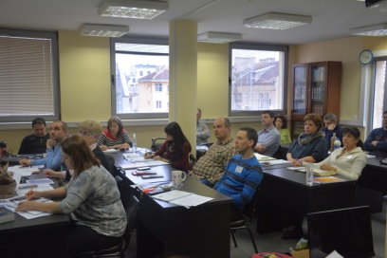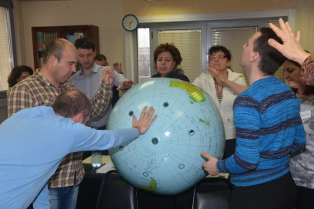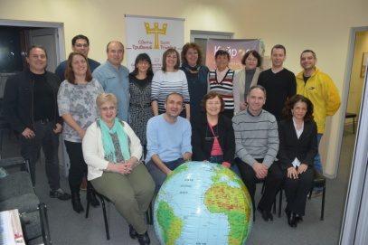

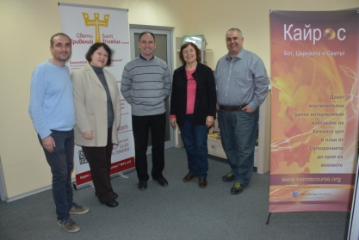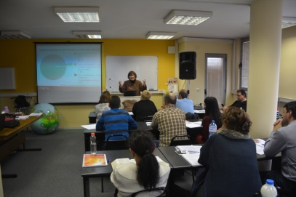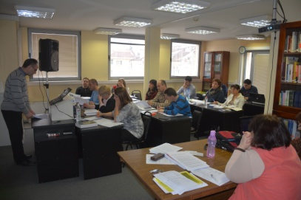

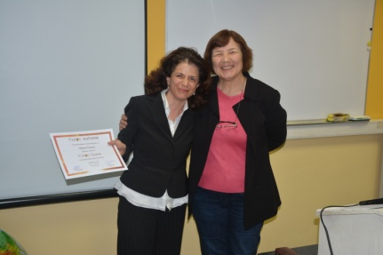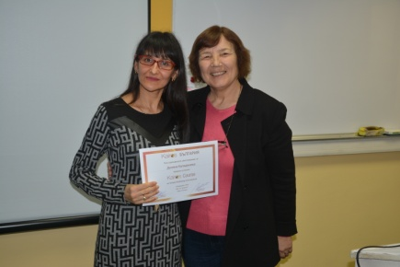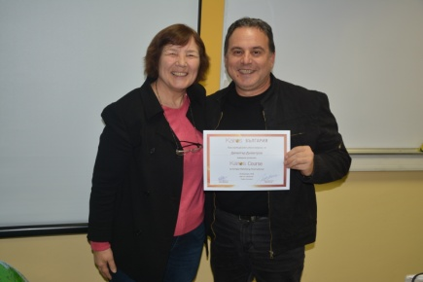

- Human Traffic – Prevention
We continue our work in Human Traffic, so called “modern slavery”. Our main focus is on prevention because it is a great tool for minimizing the number of the victims from Bulgaria sent to Western Europe. During the first quarter we had several activities in that area.
- We had a special presentation for HT at Regional Woman’s Conference in Plovdiv with 190 women from 18 churches from 5 different denominations. One of the sessions of Woman’s conference was dedicated on HT and a presentation was done by Marina Dimitrova. Most of the ladies have never heard about that modern slavery but many were from Gipsy and Turkish background and they knew the terrible results of it. Some ladies shared stories about their relatives and friends who were victims of HT or pimps. Women were shocked of the statistics that so many Bulgarian girls are forcefully taken to Western countries to be prostitutes.
Brochures with information for HT was distributed to the ladies together with the free number for calling for help on hot telephone line.
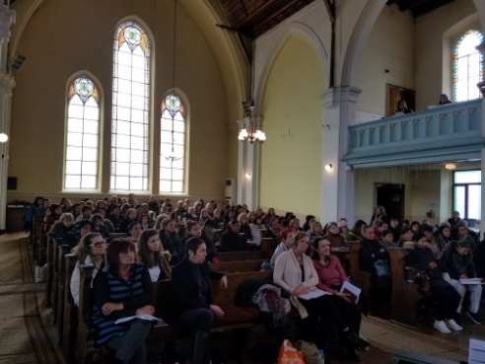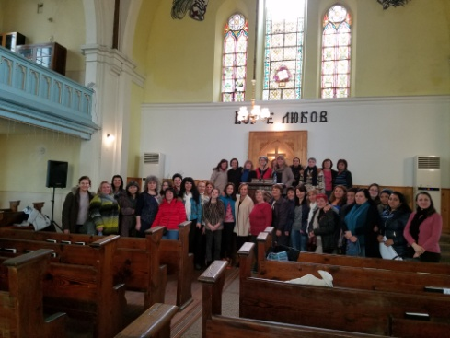

- Seminar on HT in the city of Pomorie
We gathered Gypsy people, from former Muslim background, and gave them information about the ways of protecting themselves from bad people with bad intentions, whose goal was to kidnap girls and take them abroad for prostitution. We made a presentation and gave the people statistics on HT and distributed stickers with hot telephone line for HT victims: 0800 20 100. We show a movie for real cases of young girls in prostitution who were kidnapped or lied for a good job abroad and were forced in prostitution. We also distributed brochures, booklets and other materials. 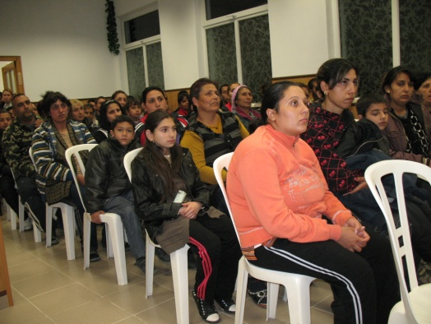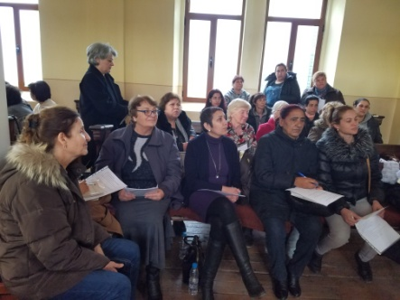

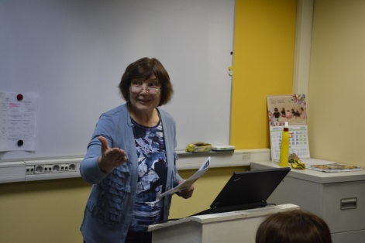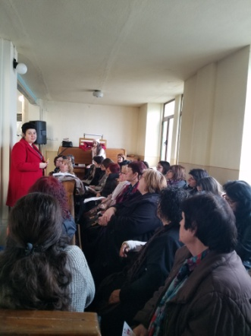

Future Plans.

- Visiting children in the orphanages in Karlovo, Zelenikovo and Brezovo.
- Helping for the surgery of Bobie from the orphanage in Karlovo in April
- Prevention work in HT for the children in the orphanages and Gipsy communities.
- Visiting Harmanly refugee camp and helping the refugees with physical and spiritual help.
- One Kairos course in June in Plovdiv.
- Please, pray for us to be instruments for fulfilling all those activities for God’s glory and blessing the children, refugees, Gipsy children and communities, churches in Bulgaria and Bulgarian nation! Thank you in advance!

