LOGOS Global Vision - BULGARIA ACTIVITY REPORT

July– September 2018

Situation in Bulgaria
We believe spiritual atmosphere in Bulgaria is different, and will be different from this year on, after 6 regional prayer days in 6 big cities during the year and a National Prayer Day in Plovdiv on 22d September. Bulgarians celebrated 130 years of independance from Ottoman Empire on that day. 6000 Chrsitians from all parts of Bulgaria came to Bulgaria to pray for blessing of Bulgarian people, our government, politicions, different areas of our social life, families, children, young people, educational and medical areas, etc. Christians came from different churches and denominations. Spirit of unity was pourd out over all prayer participants and that was one of the mosr important experiences during that day.
All participants prayed for revivle of the Church of Bulgaria in order to influence the whole siciety, all different groups of Bulgarian nation. We expect God’s blessing in our work for expending His Kingdom in Bulgaria!

- Zelenikovo, Brezovo and Karlovo Orphanages
- During the third quarter of 2018 our work with children in the three orphanages we regularly visit was not so intensive. The reason for that is that children are going to different summer activities, such as summer camps, trainings, excursions and other, which
are organized by social agencies, NGOs, municipalities.
We traveled to see them two times in the summer, in the beginning of July and in the end of September. As usual, LOGOS Global Vision volunteers spent two hours with children in each orphanage, as it was allowed for us by the staff there. Playing different games and sports outdoor with the children, teaching them different songs, and having discussions on different topics were part of our visits.
In September we took school materials to give to the students for the new school year – notebooks, pencils, pans, and some other needy for school materials. First grade students were the most excited because they liked going to school and learning to read and write.

Here are some thoughts from the children:
- Албена (7) - Thank you for taking time to come and visit us. You also brought us notebooks, pencils, pens, bananas, candies. I like spending time with all of you because you come specially for us. You teach us new songs, play sports with us, bring presents to us any time you come to visit us! Thank you!
- Lilly (11) - During the summer vacation we were out of the orphanage for a long time and we could not meet each other. I missed you a lot because you built closerelationships with all of us and I feel your love to me. Thank you for bringning school materials and different treats to all of us. You are so thoughthful!
- Todor (15) - I am living in orphanage during my whole life and I had not seen such a careful people like you. Thank you for being friends to me and helping me to overcome my low selfesteem and teaching me how to behave in a porper way.

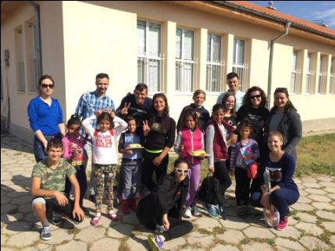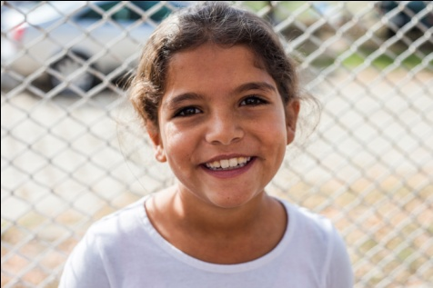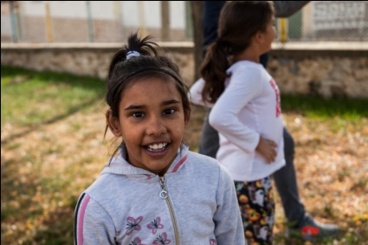

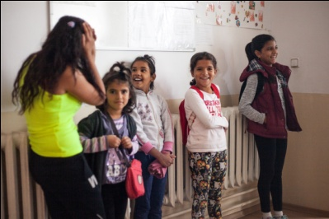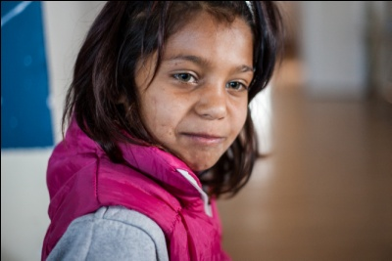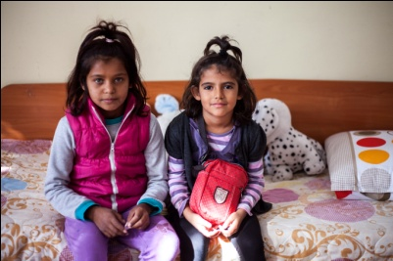

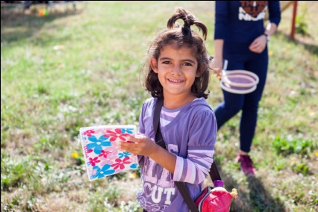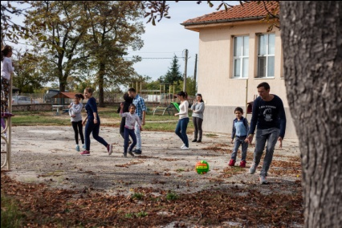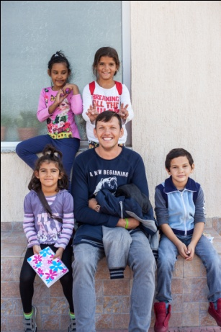

- Helping Bobie after his foot surgery
As you remember from our previous report, the surgery of Bobie’s food from the orhanage in Karlovo was already done and Bobie is recovering well. The doctor prescribed him a physiotherapy and the staff in the orphanage is going good job for Bobie to get betther. Several days per week a specialist goes to the orphanage and gives special treatments for helping Bobie start moving his feet and try walking.
The doctor also prescribed orthopedic shoes for Bobie in order to be stable when he is ready to try walking because he never walked by himself during his entire life. Shoes will cost around 100 EUR and we would like to help him have them and try making his first steps by himself. On October 26th we will take Bobie to orthopedic shoe shop in Plovdiv in order to get his measures and design his shoes to be according to his needs.
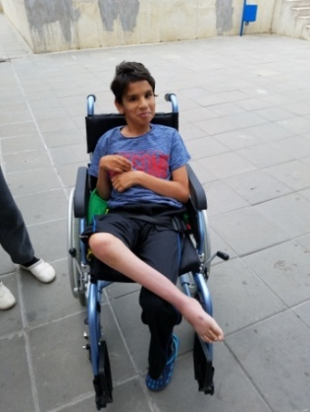
- Refugees in Bulgaria

The number of refugees in Harmanly refugee camp is going down. There are about 250-300 refugees there who still need our help. The reason for the small number of refugees, as I explained in my previous report, was because of the border wall Bulgarian government built for preventing the illegal crossing the border with Turkey and also because of the agreement between Turkey and EU for keeping the refugees in Turkey.
For those refugees who are in the camp in the city of Harmanly, LOGOS Global Vision – Bulgaria volunteers, who are former graduates from the Bible school in the church of Haskovo city, including their pastor Veselin Jotov (also graduates) continue helping them regularly with clothes, food, baby milk, dippers, and hygienic-sanitarian materials. At the same time they supply spiritual care for the Christian refugees and share the good news with Muslim refugees. They also help refugees who are Orthodox Christians from Syria, Iran and Iraq to be born again not just Christians by name or born in a Christian family. They teach them on forgiveness because almost most of them lost their family members in the war. It is wonderful to see the changes happening in their hearts and lives.

Please, pray for peaceful and effective work and ministry among refugees in Bulgaria!
No photos were allowed to be taken. The staff at the camp strictly watched us and did not allow us taking photos of the work we are doing in the camp for the refugees.

- LOGOS Bible School – Summer Internship

Logos Bible School year finished in June with 30 graduates from 4 schools. Summer was a time for their internship, a time for practicing what they learned at school.

Students are from different ethnic groups – Bulgarians, Turks, Gipsies and they had their practice in different areas of ministry in different small churches and especially in Rodppa Mountain evangelizing Bulgarian Muslim people – named Pomaks, living in the mountain.

locally”. Logos Bible school taugth me to pray regularly every school day and to live my life according to God’s word and His plan for the world and His church.

Students from Logos Bible school had their practice in the Rodoppa Mountain, after getting knowlwdge from the Bible during the school year. Four weeks internship was done in July-August in different places by different students who spent their time for evangelizing the people and helping the small churches already planted by students from previous years. The Rodoppa mountain, a region with 90% Muslims (Bulgarian Muslims, named Pomaks and Turkish Muslims who have lived in bulgaria since the end of Otthoman Empire is a great beautiful place where people need to hear the Gosple.
Zlatograd, Smolyan, Devin and Dzhebel are the places students could have their practice. Those arre moiuntain small cities.
Zlatograd is a town in Rodoppa mountain, Southern-central Bulgaria. It is the administrative centre of the homonymous Zlatograd Minicipality. The town has a population of 7,110 inhabitants which is half Orthodox and half Pomaks.
Dzhebel is a small town in Eastern parts of Rodoppa mountains, Kardzhaly Province.There are 3 300 people living there which are Turkish Muslims. There are just few Bulgarian Orthodox Christians there.
Smolyan is a town and ski resort in the far south of Bulgaria near the border with Greece. It is the administrative and industrial centre of the homonymous Smolyan Province and it has a little more than 30 000 people. Two thirds of the population are Orthodox Christians and others are Bulgarian Muslims, named Pomaks. There are three small evangelical churches with about 80 believers total.
Devin is a spa town in Rodoppa Mountain in the far south of Bulgaria. It is the administrative centre of the homonymous Devin Minicipality. The town has a population of 7,054 inhabitants which divides in Orthodox Christians and Pomaks. There is just one evangelical church there with 30 believers.
Nedelino city is a small city in Rodoppa mountain with 6000 people living there. Most of the population is Pomaks, Bulgarian Muslims.
All those places need to be evangelized and churches need to be planted there. That is the reason Logos students spent their summer internship there doing different activities – evangelism and helping the small churches to train their believers in God’s word and helping them grow spiritually in the Lord. Hundreds of brochures and bulletins were distributed and many personal testimonies were shared by the students to the local people. Students prayed for the needs of many people and also for sick people on the streets and bazaars. Some of the people were healed from headaches, stomachache, pain in the legs and in the back.
During one of the weekends in Rodoppa mountain students had a special prayer support from several families from the church in Plovdiv. Students organized a special concerts for the local people in Rodoppa mountain with different styles of music – classic music, folklore music, pop music. The good news for Jesus Christ was shared and people were called to accept the Lord.

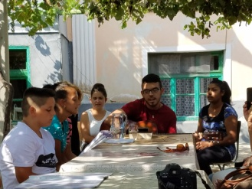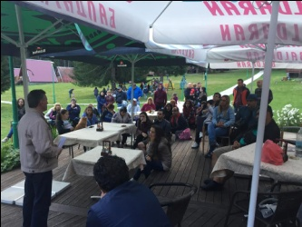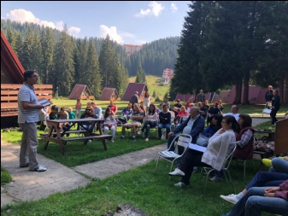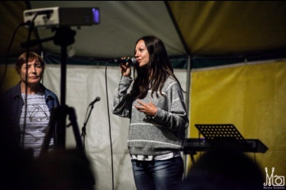

- Kairos course
Logos Bible School in Bulgaria is involved in organizing Kairos courses in Bulgarian churches as partner with PAOB – Pentecostal Assemblies of Bulgaria. Kairos course is included now in the training program of Logos Bible school. It is a course for motivating believers and churches for Missions. Kairos course was done in the beginning of July 2018 in Varna on the Black Sea. Seventeen participants from two different churches were involved in Kairos training from two denominations. That course was the first one in the North East Region of Bulgaria. As planned this course continued the expansion of training and motivationg believers for missions. The participants responded very well to the course schedule, teaching materials, Grouth Point Group time and discussions as well as leading the prayer and worship times each day. The participants had a great desire to learn and grow as well as go through every Kairos component with excellence. Cross cultural experiences were those who none of the participants had before and they were the most interesting experiences durng the training. Here are some testimonies:

Elena Marinova: "One of the most important course experiences in my life. Kairos changed my perspective for ministry, missions and church."
Nikolinka Toneva: "I wish I could go through Kairos course again so I will experience God of the Mission again in the same way."
Margarita Ivanova: "Amazing experience. Kairos brings personal transformation."

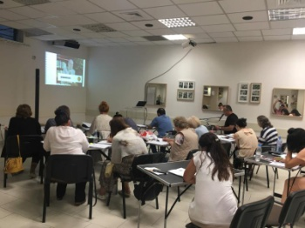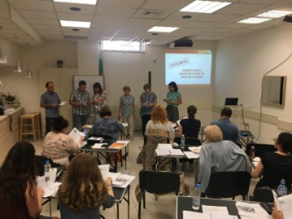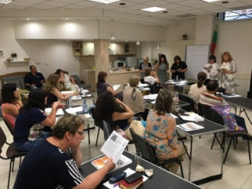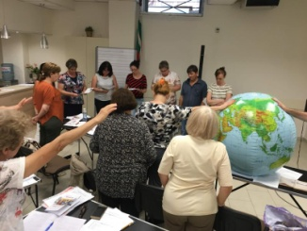

- Children’s Summer Bible Study

Bible study for Roma children was organized in the vilalge of Shishmantsy, 17 km from Plovdiv. It was for three days between 28-30 September, 2018. Two young people, former students from Logos Bible school were the teachers, Ilija and Tsvety Russev. Children were divided in two different groups because of the age. They studied two different books. Children from age of 9-10 studied the book of Jona „No Way, Jona”- 9 children. Children from 11-12 year old studied the Book of John „”Jesus in Spotlights”.
All children were so excited to study the books. Each of them received a book, a box of color pencils, and a pen. Ilija and Tsvety are very diligent as teachers and they taught in a very interactive way. Children were so curious to learn more about Jonah and the way they could study the Bible.
During the breaks we gave the children food and different snacks and drinks! They also got sweets and small treats. Children who were active in answering questions and doing their work diligently received small gifts.
Testimonies:
George (11) – I like the book we studied, „Jesus in Spotlights”, because it shoes me what Jesus did for me on the Cross. In the end of the book there was a prayer for accepting Jesus as our Savior. I prayed and I accept Him to be my Savior and Lord. I like the way teachers teach us to understand the Bible.
Assen (9) – I thank you for giving us a book about Jonah as a gift. Thank you for teaching us how to study the book in a special way in order to understand it. I have never read anything from the Bible but now I understood how to read it and how to study it. Teachers are very good in explaining us all the terms and words. They also made different crosswords and games and they all helped us to see how we could apply what we learned in our life.

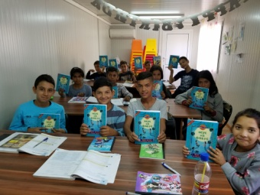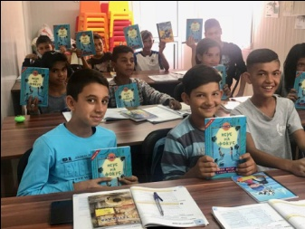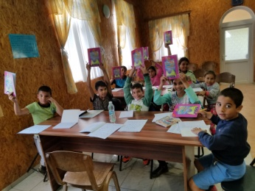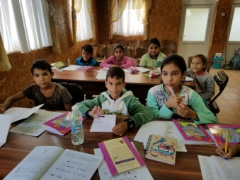

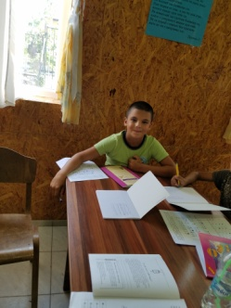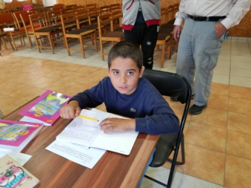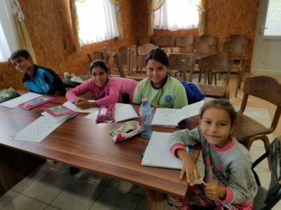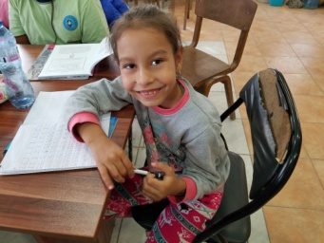

- Human Traffic – Prevention - Seminars on HT in the villages of Yasno Pole and Tsarimir
We continue our work in Human Traffic, so called “modern slavery”. Our main focus is on prevention because it is a great tool for minimizing the number of the victims from Bulgaria sent to Western Europe . The name of the project is “OPEN EYS” During the third quarter we had two activities in that area – one in the village of Yasno Pole and the other one was for the people in the village of Tsarimir which are about 20 km from Plovdiv in different directions. We made a ppt presentation on HT in both places. In the village of Yasno pole all people from Gipsy community came to hear about the modern slavory. In the village of Tsarimir there were about 25 people participating for the presentations.
We gave them information about the ways of protecting themselves from bad people with bad intentions, whose goal was to kidnap girls and take them abroad for prostitution. We distributed brochures with important information on prevention and stickers with hot telephone line for HT victims: 0800 20 100. We show a movie for real cases of young girls in prostitution who were kidnapped or lied for a good job abroad and were forced in prostitution or worked for little money but the rest were taken away for the people who lied them.
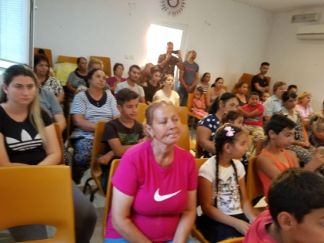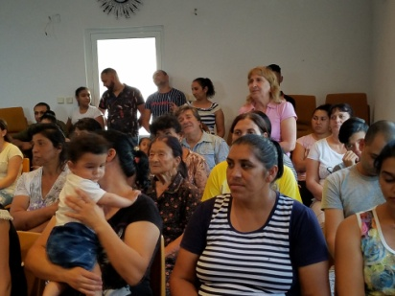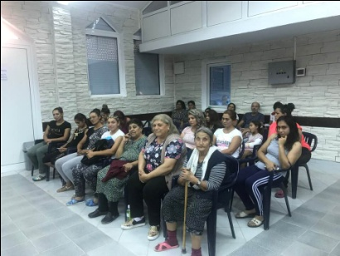

Future Plans.

- Visiting children in the orphanages in Karlovo, Zelenikovo and Brezovo.
- Distributing Christmas gifts to the four orphanages we visit regularly
- Helping for the orthopedic shoes of Bobie after foot surgery from the orphanage in Karlovo.
- Starting new bible schools in Sliven and Karnobat – first time there.
- Bible Study for Gipsy children.
- Prevention work in HT for the children in the orphanages and Gipsy communities.
- Visiting Harmanly refugee camp and helping the refugees with physical and spiritual help.
- Kairos course in November in Burgas
- WOW day in Kalekovets village with WOW team from England.
- Please, pray for us to be instruments for fulfilling all those activities for God’s glory and blessing the children, refugees, Gipsy children and communities, churches in Bulgaria and Bulgarian nation! Thank you in advance.

