LOGOS Global Vision - BULGARIA ACTIVITY REPORT

April– June 2018

Situation in Bulgaria
In the end of June 2018 Bulgarian government has already finished the leadership of EU for 6 months in a rotation principle and passed it to Austria from July 1th. Bulgarian Prime Minister raised the issue for West Balkans as one of the important problems for EU and it was accepted from all EU countries. At the same time Bulgarian people did not see almost any changes in the situation in the country neither in their lives.
Corruption and crime are still big problems in Bulgaria and Government has not done its best for resolving those problems. Security of the country was the issue former communist raised in the parliament as a reason to give a vote of non-confidence to the government.

One of the biggest problems during April-June 2018 was the protest of mothers having disabled children in their families. The reason for the protest was the insufficiency of financial and medical support Government has given for those families who are taking care of their disabled children. The whole families went on the streets to protest because there was no good social and medical care for their disabled children. Many Bulgarians also supported those families in their protests. Unfortunately, the issue was not resolved and the protest continues. Bulgarian government was not able to pass a good law for that issue and many disabled children live in very poor situation and are suffering of lack of medicines and good medical care.

- Zelenikovo, Brezovo and Karlovo Orphanages
- During the second quarter of 2018 we visited orphans in Karlovo, Zelenikovo and
Brezovo three times, once per month. As usual, LOGOS Global Vision volunteers spent two hours with children in each orphanage, as it was allowed for us by the staff there. In April the visit was for Easter when children received Easter gifts for Easter and were happy to spend time with our volunteers who shared Easter story to them. We also took them out for a picnic in the near park. Sandwiches for the picnic were prepared with a lot of love by Sunday school children from Holy trinity Church in Plovdiv. Each sandwich had a pink heart with a sigh “Prepared with love”. Orphans were impressed by their love and thoughtfulness!
In May we also took the children outside of the orphanages and we had a picnic in the city park of Karlovo. We bought food and drinks for all children and spend time together in the park next to one of the orphanages. Playing different games and sports outdoor with the children and having discussions on different topics were part of our visits.

At the end of our visit in May we took the children to Karlovo square where was Festival of Roses with many people, music, songs, foreigners, ice cream, candies and many other funny things. They were so happy there
Here are some thoughts from the children:
- Anastasia (14) “Thank you so much for the wonderful picnic you arranged for us! We had great time together with our friends from the second orphanage in Karlovo and with the volunteers from Plovdiv. They are healty and they helped disabled children from our orphanage. We all played different games and sports and we had fun together. I like playing federball with volunteers. Thank you for thinking of us!”
- Stoyan (11) “Thank you for coming and organizing a picnic for us. You come so often and any time you come we have great time together. Sandwiches you gave us were so fresh and tasty. I like sandwishes and like eating them! I personally enjoyed the time together. Thank you!”
- Pencho (15) “You are one of the few people who come to visit us here in the orphanage. I appreciate the time you spend with us. Thank you for taking us today to the Festival of Roses in Karlovo city. We saw interesting new things there and even people from different countries. I saw Japaneese people coming from Japan for first time in my life. I am so thankful for you. You help me to see more from the life of the people outside of our orphanage where we live just 15 children! Thank you!”
- Iva (12) – I am impressed by the children from Plovdiv who made sandwiches for us. They also made a pink heart for all samdwiches and wrote “For you with love” and “Prepared with love”. They have never met us but they love us and think about us! Thank you! I would love to meet them and thank them personally!”
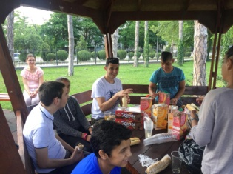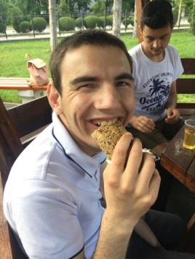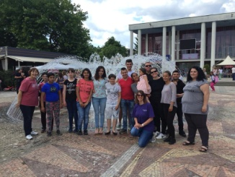

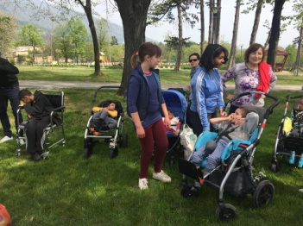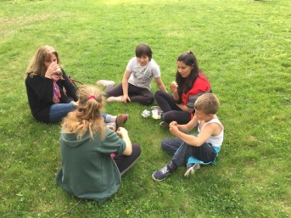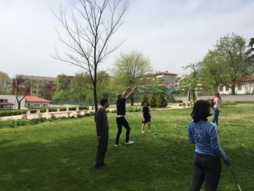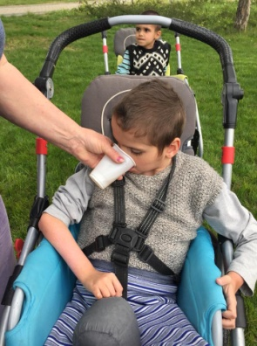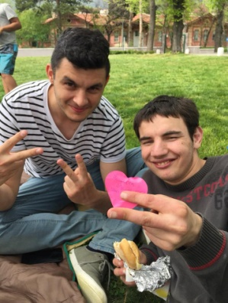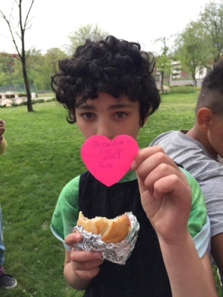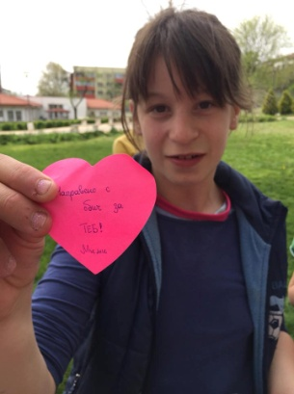

- Helping Bobie after his foot surgery
The surgery of Bobie’s food from the orhanage in Karlovo is already done. The doctor did several operations at once. He stayed in the hospitale for two weeks and we were able to visit him there with two other volunteers, Villy and Tanya. Bobie stayed with a plaster on his food more than a month and special metals for a connections in order to keep the food in normal position. He received a brand new willchare as a gift from Mr. Adam Smith from Englad through our organization and he was very happy with it.
Right now Bobie is recovering, the plaster and metal connections are off and he has some rehabilitaion. He feels much better but he still can not walk by himself until special orthopedic shoes are made for him because his right leg is shorter then the other one. We would like to help for the special ortopedic shoes for Bobie and see him out of will chair and start walking properrly by himself or using craches.

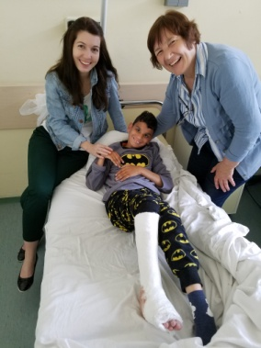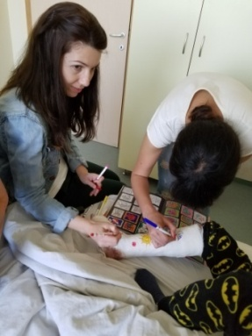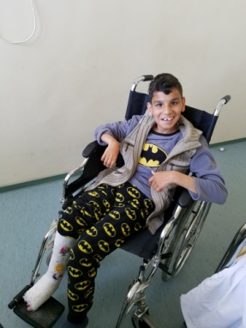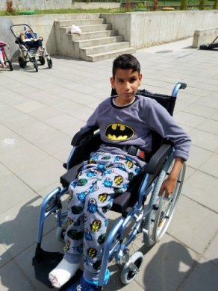
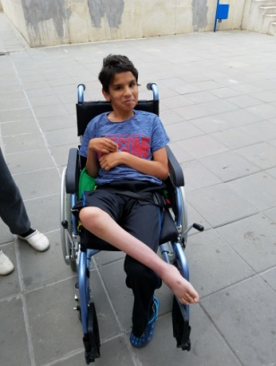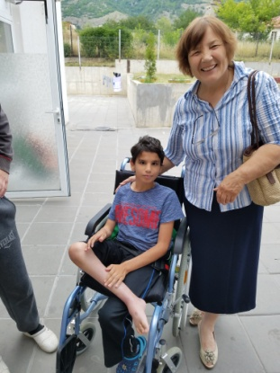

- Refugees in Bulgaria

The number of refugees in Harmanly refugee camp is going down. There are about 250-300 refugees there who still need our help. The reason for the small number of refugees, as I explained in my previous report, was because of the border wall Bulgarian government built for preventing the illegal crossing the border with Turkey and also because of the agreement between Turkey and EU.
For those refugees who are in the camp in the city of Harmanly, LOGOS Global Vision – Bulgaria volunteers, who are former graduates from the Bible school in the church of Haskovo city, including their pastor Veselin Jotov (also graduates) continue helping them regularly with clothes, food, baby milk, dippers, and hygienic-sanitarian materials. At the same time they supply spiritual care for the Christian refugees and share the good news with Muslim refugees. They also help refugees who are Orthodox Christians from Syria, Iran and Iraq to be born again not just Christians by name or born in a Christian family. They teach them on forgiveness because almost most of them lost their family members in the war. It is wonderful to see the changes happening in their hearts and lives.

Please, pray for peaceful and effective work and ministry among refugees in Bulgaria!
No photos were allowed to be taken because of the new law EU passed for personal data. The staff at the camp strictly observed it and did not allow us taking photos of the work we are doing in the camp for the refugees.

- LMTC - LOGOS Bible School

Logos Bible School year finished in June and we had 4 graduations for the all 4 bible school.
- Plovdiv school - 5
- Pleven school – 4
- Krushovitsa – 6
- Pomorie school – 15
-----------------------------------

4 schools - 30 students

Students are from different ethnic groups – Bulgarians, Turks, Gipsies and they studeid diligently and at the end of the school year they received their diplomas. Gradueds better equiped for serving God and fullfiling His Great Commision. Here are some testimonies of the students:
  - Danail Kukov from Plovdiv school – “I was born in a Christian family and grew up in the church of Plovdiv where Logos Bible school trains believers since 1992. My father alwayes wanted to study that school since the beginning of it but because of his job in three shifed. He incouraged me to study there and after I graduated High school last year I decided to be part of the training. At the same time I am a first year student at Plovdiv Technical University of Plovdiv. Logos Bible school helped me to understand the Bible in a deeper way and to see the bigger picture of God’s Kingdom. I learned a very important thoughth “Think globally, act locally”. Logos Bible school taugth me to pray regularly every school day and to live my life according to God’s word and His plan for the world and His church.

  - Spaska Nikolova from Plovdiv Logos Bibloe school: My husband graduated from the Bible school back in 1993 with the fisrt graduates ever. We were not married that time but I was so empressed by his knowledge on the Bible and his dedication of serving God. I got jelouse to get similar knowledge and spirit of prayer as the school is teaching them. Studying there was the only way to get those spiritual advantages. Training is for nine months and it helped me to grow spiritually and get knowledge I was longing for. Thank you, teachers! You were such a blessing and such a good example to all of us as your students!”

  - Zlatka Tateosyan: My family is very closely connected to Logos Bible School. My husband teaches different topics for Logos bible school. He travels to several schools in different places to do that. My two children graduated from Plovdiv bible school and alwayes encouraged me to study it. Las year I decided to study and I am so thankful to God for all I learned there! I also very much value the relationships between students and teachers and among the classmates. I also got very good knowledge from the Bible and I got very good friends from my classmates. Teachers are wonderful Chrsitians and motivate us to become like Jesus, to serve Him for expanding God’s Kingdom in the world! Now I am looking forward to the internship in July in order to practice what I learned in the school – evangelizing people and helping needy people.”

  - My name is Dimiter Mitkov and I am Gypsy Chrsitian. As a little boy my parents took me to the musk because they were Muslims. I did not understand anything I had to do there but I did it because all people did it. In 1998 my parents became Christians and they tald me about Jesus Christ. I saw them so happy and so changed. The reason for that was Jesus Chrsit whom I accepted soon after my parents. After I graduated from High school I could not find any job and I decided to study at the bible school in Pomorie. I learned many new things I did not know before. Teachers are very good and they teach us God’s Word and help us to understand God’s plan for salvation of all people from all ethnic groups. One of the topics I like the most is Missions. It helped me to understand that God has called me to serve Him and make disciples from all nations. Please, pray for me to fulfill God’s call in my life.”

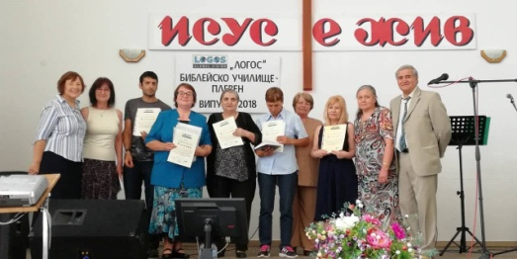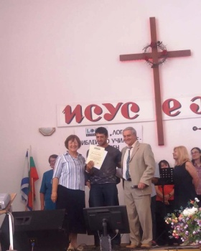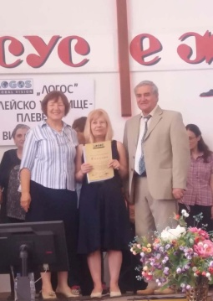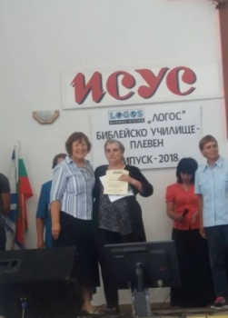

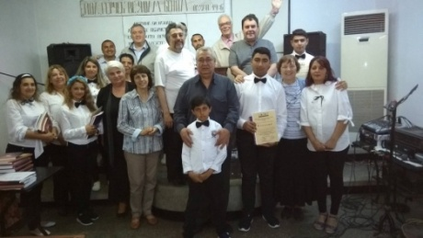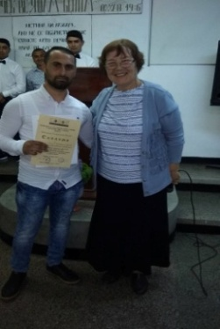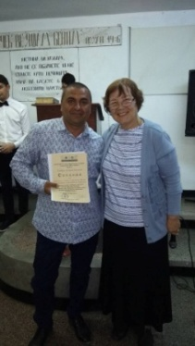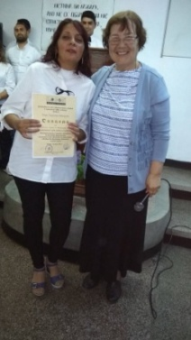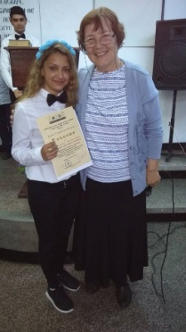

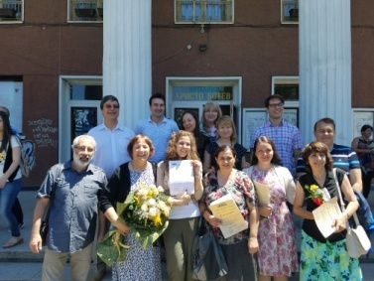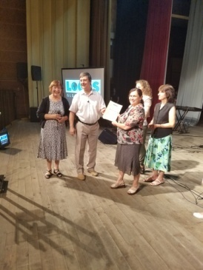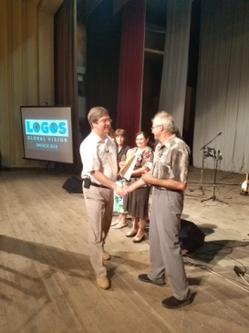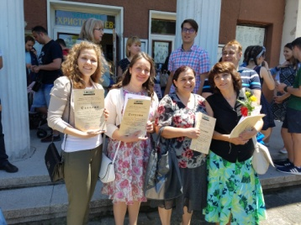

- Kairos course
Logos Bible School in Bulgaria is involved in organizing Kairos courses in Bulgarian churches as partner with PAOB – Pentecostal Assemblies of Bulgaria. Kairos course is included now in the training program of Logos Bible school. It is a course for motivating believers and churches for Missions. Kairos course was done in the beginning of June 2018 in Plovdiv. All Plovdiv students participated at the course together with some other believers from Plovdiv churches. Eighteen participants from two different churches were involved in Kairos training from two denominations. Cross cultural experiences were those who none of the participants had before. Here are some testimonies:
  - Stoyan (28) –“ I loved the Lord and I thought that was all I needed to do as a Christian. My best friends signed for Kairos course and they almost forced me to participate too. Kairos course helped me to become “world Christian” – a believer who is oriented to the goal of reaching the world for Christ. Kairos course is very practical and very good for people who have heart for unreached people’s groups. I admit that I did not have such a heart but by God’s grace I was changed and now I love all people and I want them saved by faith in Jesus! Thank you for the bible school that organized that training for us.”

  - Diana (29) – I am an intellectually oriented Christian. I always wanted to learn more and more just for myself. A friend of mine told me about Kairos course and I said to myself “Here is another possibility to learn more for myself. I am kind of egoistic Christian, just wanting blessings for myself! Going to Kairos course challenged my ego. I realized I was so self centered but at the same time so many ethnic groups did not heard about Christ and His way of salvation by faith. I was ashamed when I realized how selfish I was! I was challenged to go out of my comfort zone and do at least something for those people who didn’t know Jesus. I decided to stared praying and giving for Missions first! I decided to look for refugees here in Bulgaria that I could help and share the Good news about the Lord! Kairos course was such a challenge to me! Thank God for being part of it! ”

  - Plamen (45) I have a heart for Missions! I have done some mission work in Bulgaria among Muslims but I did not have the full picture of World Missions. Kairos course gave me that picture and now I understand God’s heart for the unreached peoples groups in the world. Through Kairos course God gave me the right direction for serving Him. I had one challenge during the course – practical cross cultural experience that I did not expect to have! I had to overcome some fears and hesitations. Thank you for giving the opportunity to do that through Kairos course!

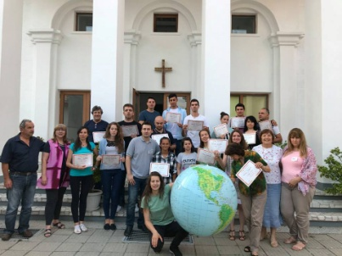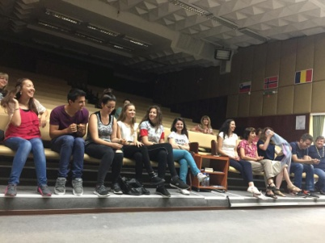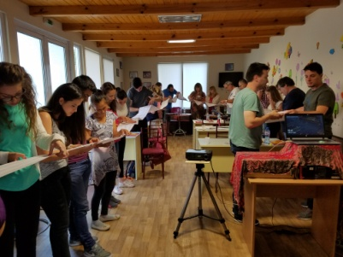

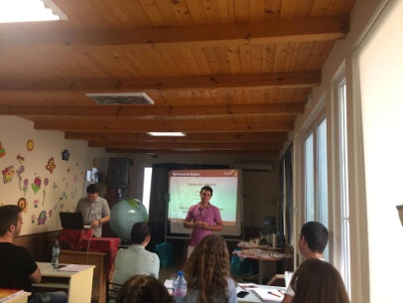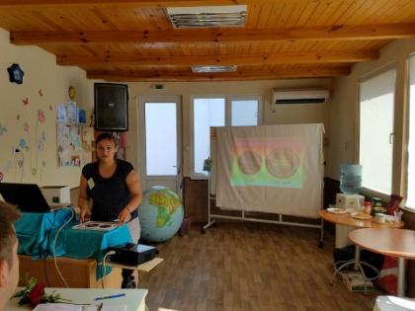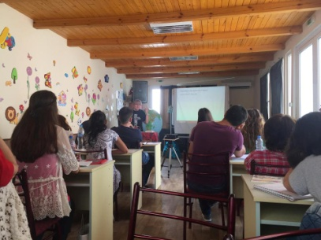

- Children’s Summer Bible Study

Bible study for Roma children in Montana area, Gabrovnitsa village, was organized by sister Geroika Shishkova for 21-23 June, 2018. Two young people from Plovdiv church were the teachers, George and Daffo. Bible study started on Thursday, 21 June in the afternoon at 5.00 p.m. with 25 children from Roma community in Gabrovanit. Some of the parents also came to see the process of studying. Sister Geroika also participated at the training because she wanted to learn the inductive method for studying the bible abd continue teaching the children in the future. She prayed for blessing the children during the studies and for the opening of the study.
All children were so inpatient to study the book of Jonah. Each of them received two books – Jonah and How to study the Bible for children, color pencils, and a pen. George and Daffo are very diligent as teachers and they taught in a very interactive way. Children were so curious to learn more about Jonah and the way they could study the Bible.
During the second and third days the number of the children was different during different time of the day – from 22 in the morning to 33 during break time and 21 at the end. There were some new children who were first time coming to church and their parents were not believers. We all prayed for them and gave them books and food during the breaks!
During the breaks we gave the children food and different snacks and drinks! They also got sweets and small treats. Children who were active in answering questions and doing their work diligently received small gifts.
Most of the children were active in following all the bible study. They were very attentive and fulfilled all assignments teachers gave them. They had to memorize some bible verses overnight at home and most of them did in perfectly. Some of them cited the verses in the morning on front of all children and were very proud of themselves.
Some of the children were noisy, and others got up from the chair and went out and later came back. Few of them even could not read and write properly although they were in a school and they should be able to do that. At the end of the Bible study at 3.00 p.m. on Saturday we all were so blessed. We finished with a prayer in a circle holding our hands together. Some children prayed for teachers and invited us again.
Sister Geroika shared: Thank you for coming and helping with the children. I am alone here and I am not able to accomplish the work the Lord has here for those people. Workers are few but the work is big, I need help. Thank Swedish brothers who offered that help. Thank you, Marina, for coming and doing that training with Gypsy children!
Some testimonies:
- Angela – 14 year old girl: I come to all meetings sister Geroika has for us here. This bible study is very, very interesting. I have never participated in a similar training. It helped me to start looking at the Bible in a very different way. I have not read any book from the Bible but just read separate verses from time to time. Now I know the importance of reading and studying God’s book systematically.
- Iliana – 9 year old girl: This Bible study was my first time studying the Bible. My mother always takes me to church but I have not understood anything there. This week I got clear picture of Jonah’s story and specially I learned the massage for obeying God in any circumstances.
- Stefan- 12 year old boy - The two books we received as presents are so nice and the training helped me to learn so many new things! Teachers are so patient to us and explain us very well the way we should read and study the Bible.
- Peter -10 year old boy: Thank you for giving us an opportunity to study the book of Jonah in such an interesting way. Playing the role of journalists and preparing reports for a newspaper while we were studying the book about Prophet Jonah was very interesting idea . We also had to draw pictures for the ship-wrecking and the fish swallowing Jonah and to fulfill crosswords. Teachers also explained us how to find important words and answer important questions. It was great fun!

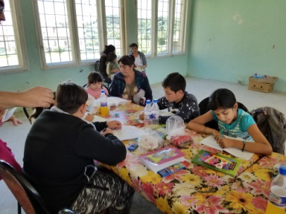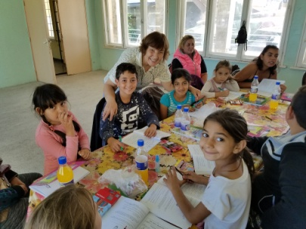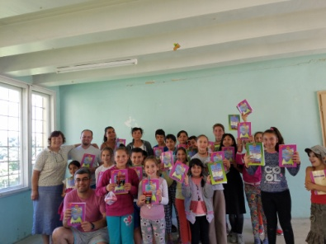

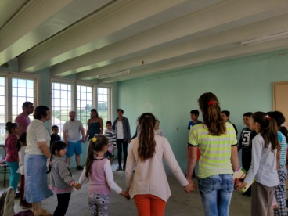 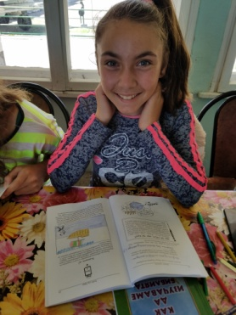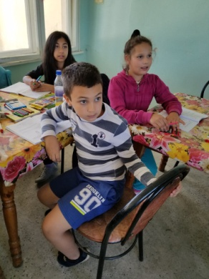 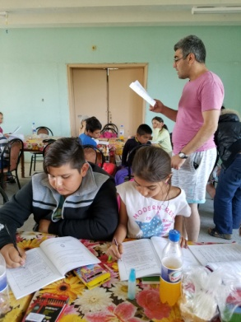 7

- Human Traffic – Prevention
We continue our work in Human Traffic, so called “modern slavery”. Our main focus is on prevention because it is a great tool for minimizing the number of the victims from Bulgaria sent to Western Europe. During the second quarter we had two activities in that area – one in the village of Krushovitsa using the students from the Bible school there and the other was in the village of Gabrovnitsa.

Seminar on HT in the villages of Krushovitsa and Gabrovnitsa
We gathered Gypsy people, from the village of Krushovitsa, Pleven region, and the village of Gabrovnitsa, Montana region, and we made a ppt presentation on HT. We gave them information about the ways of protecting themselves from bad people with bad intentions, whose goal was to kidnap girls and take them abroad for prostitution. We distributed brochures with important information on prevention and stickers with hot telephone line for HT victims: 0800 20 100. We show a movie for real cases of young girls in prostitution who were kidnapped or lied for a good job abroad and were forced in prostitution.
In the village of Gabrovnitsa we had about 30 young people for the presentation. We also had personal conversations with two women who recently came back from Belgium and shared their own experiences in similar situations of HT. They went to Brussels to look for jobs and were almost trapped in HT but they were able to escape as soon as it was possible and they did not become slaves of it. One of them (Katya) shared “ I participated at a small seminar similar to that in the city of Knezha two years ago. I remember your volunteers teaching the participants of the seminar to be careful when they go to work abroad. You gave us instructions how to look for safe 3work and how to make copy of our personal ID documents. When I went to Brussels last year to look for job I remembered all those instructions. With your teaching and brochures you gave me in Knezha, you helped me not to be involved in bad situations as many other women were. The owner of the restaurant I worked tried to take my passport away but I made a copy of it and I sent the address I was working in Brussels to my relatives back in Bulgaria. All those things I learned at your seminar two years ago. It helped me to be aware of the ways pimps are working and putting women and girls in slavory. Thank you for doing such seminars and distributing brochures with important information for similar situations.”

Stanka shared her testimony too: “I have not been in your seminars before but thank God for Katya who helped me in Brussels. We were together at the same time working in a restaurant close to South Train Station in Brussels. I did not have any idea that the restaurant was next to the brothels and our boss was working with pimps. Thank Katya who shared what she learned in you seminar in Knezha and she helped me to be more careful and alert and to look for better job. Unfortunately we could not find another job because we did not speak the language and did not have free time to go and look for jobs. Katy and I decided to leave the job and come back to our country. We are safe now!”
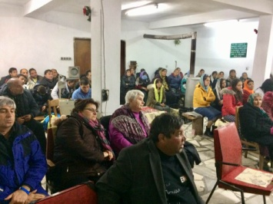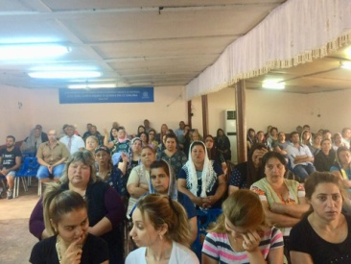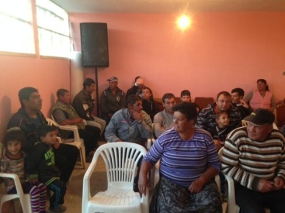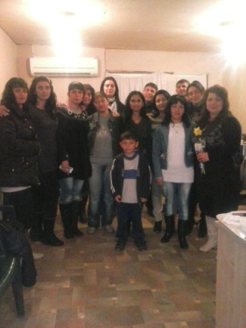

G.LOGOS Global Vision – Bulgaria – News 2018

In May we had special guests from LOGOS Global Vision – Germany, Dr. Heinrick Floreck, president and a founder of Logos Global Vision – Germany, his daughter and son in law, Claudia and Kevin Black. We had very intensive schedule with them: a seminar on Fundraising on Saturday morning, May 19, with pastors, teachers and volunteers of our organization and some other NGOs in Bulgaria; an evangelistic crusade in the city hall of Perushtitsa; a church service in Holy Trinity AOG church in Plovdiv and a Board Meeting of Logos Global Vision – Bulgaria. We have a new member of the Board, an young lady who graduated from LMTC – Plovdiv and a very faithful volunteer of our organization, Maria Todorova, from the city of Sliven. Maria is going to extend the work in Sliven, Yambol and Burgas regions of Bulgaria with LMTC, social work among orphanages and needy people, Human trafficking, etc. Welcome, Maria, and looking forward to working together for helping the needy and showing God’s love to them.
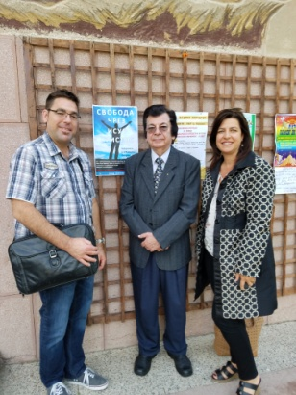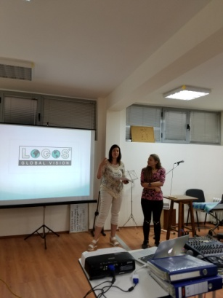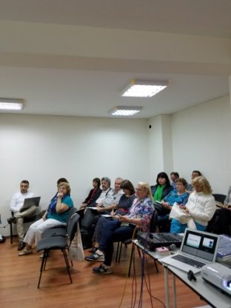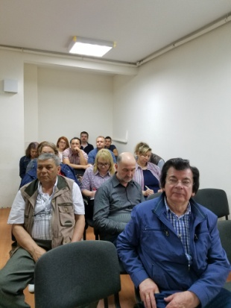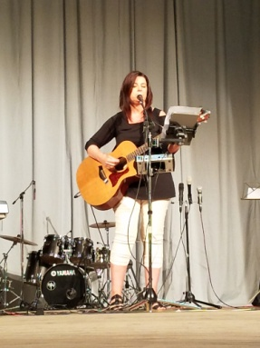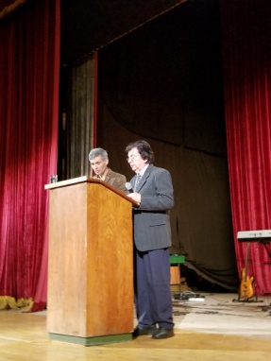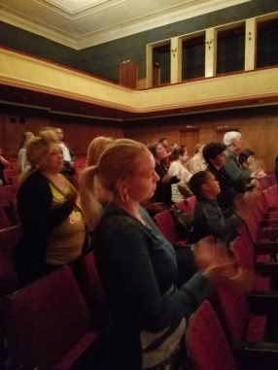

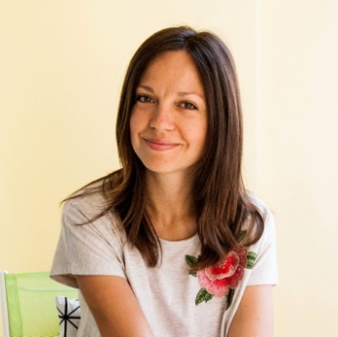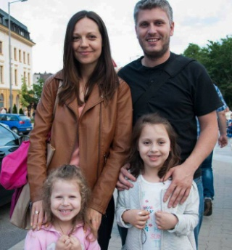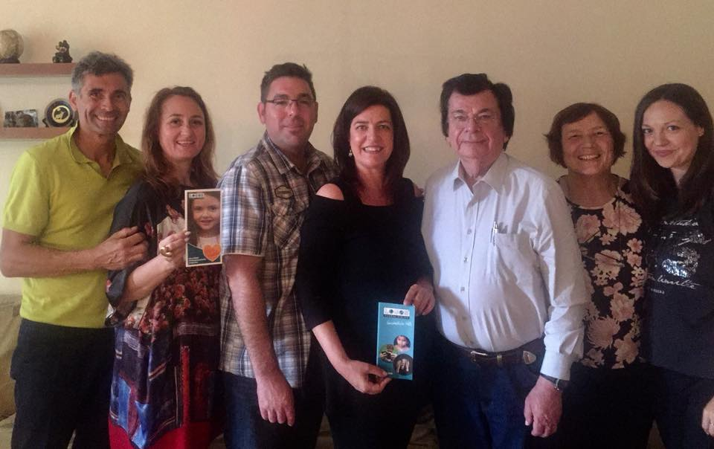

Future Plans.

- Visiting children in the orphanages in Karlovo, Zelenikovo and Brezovo.
- Helping for the orthopedic shoes of Bobie after foot surgery from the orphanage in Karlovo.
- Internship of Logos Bible School graduates in July-August.
- Summer Bible Study for Gipsy children.
- Prevention work in HT for the children in the orphanages and Gipsy communities.
- Visiting Harmanly refugee camp and helping the refugees with physical and spiritual help.
- Kairos course in July in Varna.
- Please, pray for us to be instruments for fulfilling all those activities for God’s glory and blessing the children, refugees, Gipsy children and communities, churches in Bulgaria and Bulgarian nation! Thank you in advance!

