LOGOS Global Vision - BULGARIA ACTIVITY REPORT

April – June 2019

Situation in Bulgaria
Second quarter of 2019, April - June 2019, was full of events in Bulgaria. Government tried to pass a new strategy for children for period of 2020 – 2018. It was planned
for a rudely interference in family and children relationships, taking children out of families which are having different social problems or families are poor. That action created massive protests in the country and Christians were taking active part of them.
Unfortunately the corruption is still in very high level and that affect all nation. The biggest problems are that corrupted politicians and governmental people never got charged for crime. Young people of Bulgaria are disappointed and angry of that and leave the country going to work abroad and they do not plan to come back to their homeland. The elections for EU Parliament has shown people’s disappointment and the percentage of people who went to vote for was the lowest ever in Bulgarian history.
Please, pray for our country and our Government to lead our country in a better way and fight against mafia and corruption.

- Zelenikovo, Brezovo and Karlovo Orphanages
Second quarter of the year is spring time with a special Easter celebration and we were able to visit the children from the orphanages every month of the quarter. We visited the children from all 4 orphanages for Easter and we were able to share the story about resurrection of our Lord Jesus Christ with the children and even with the staff working there. Resurrection massage of love and hope was well received by all children and workers there.
As usual, LOGOS Global Vision volunteers spent two hours with children in each orphanage, as it was allowed for us by the staff there. Seven Logos Global Vision volunteers were part of a big group of a Irish choir led by a Bulgarian couple, Nikolay and Vessie Ivanov, former teachers in our Bible school in Plovdiv, who immigrated to Northern Ireland some years ago. Nikolai and Vessie are professional musicians and they brought 50 adults, members of their choir, who wanted to visit the orphans in Zelenikovo and Brezovo and gave them as Easter gifts 20 ukulele, small musical instruments to each child. Children were so surprised and happy that some of them grabbed the ukuleles, went aside and started examine the instrument. It was a special moment to be seen. Irish guests started teaching them to pray on it and sang several songs, including some in Bulgarian language, learned specially for the children.
Logos Global Vision volunteers gave the orphans Easter gifts, kozunak (Easter sweet brad specially backed for the orphans), a big chocolate egg and fruits, bananas and apples. Children presented folk dances they will dance at a festival for all Balkan countries. It was wonderful time of fellowship. Here are some testimonies from the children:
- Anna (15) - Thank you for coming and visiting us for Easter and sharing a message of hope and love with us. Thank yiu for all those gifts – kozunaks, chocolates, fruits and specailly ukulele which you gave to all of us.
- Zhivka (17) - Thank you so much for Easter gifts you brough for us. I will never forget the people from Irish coire, their songs in Bulgarian and their love for us. Thank ou for my ukulele.
- Rumen (9) - I have never seen such a small quitare. Now I have my own and I can start learning how to play it! Thank you for that special gift! You made my day!
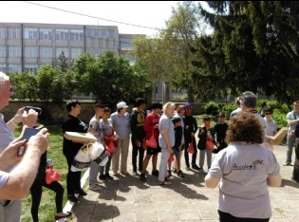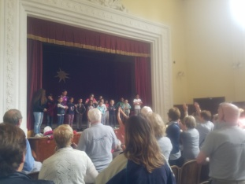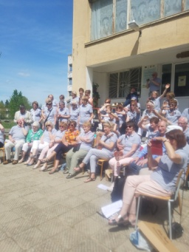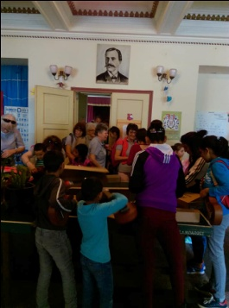

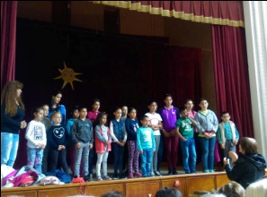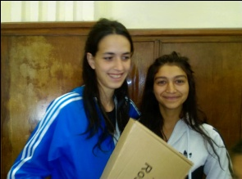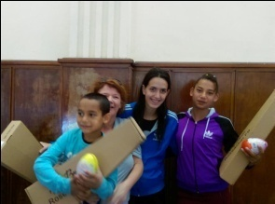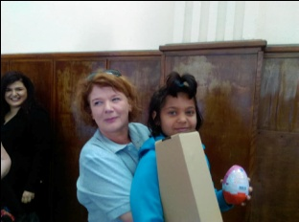

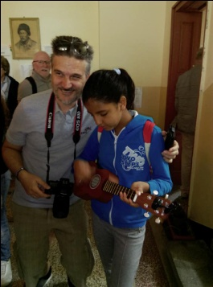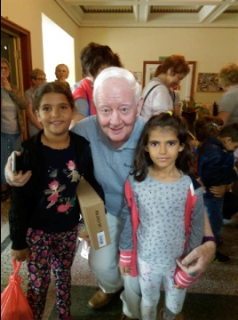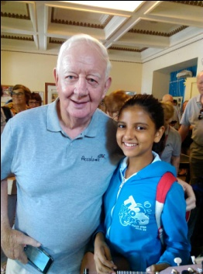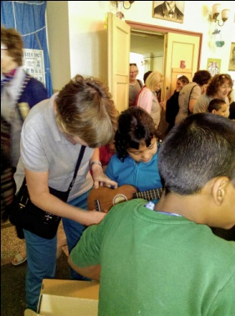

- Helping Bobie after his foot surgery
Bobie is making his progress in walking after last year surgery of his foot a year ago, in March 2018. You can see him on the short video becoming more stabel but he still can not walk by himself. Please, continue praying for him. He also can’t talk properly because he suffers of MMC.

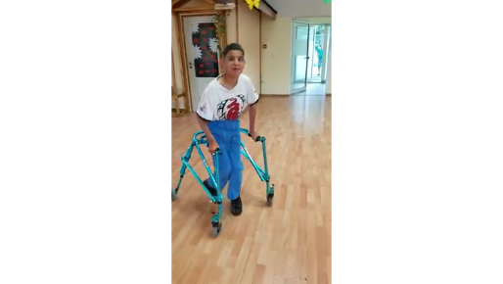

- LOGOS Bible School

Logos Bible Schools finished their school year in June. Sixty Students from 6 schools in Bulgaria in 6 differen cities - Sofia, Plovdiv, Sliven, Karnobat, Pleven and Yambol got their diplomas . It was a wonderful time of celebration of their success during 9 month training program. Herer is the number of graduates from different schools:

2 June 2019 – Pleven – 3 graduates

7 June 2019 – Sliven – 13 graduates

15 June 2019 – Yambol – 12 students

23 June 2019 - Sofia – 10 students

25 June 2019 – Karnobat – 13 students

30 June 2019 – Plovdiv – 9 students

----------------------------------------------------------

Total graduates in 6 schools 60

Students start their internship in July and they will go to different churches to help with different activities. The most important of their work will be evangelism among Muslims in Rodoppa mountains, among Gypcy communities in Bulgaria and other unreached with the good news people in Bulgaria. Schools in Sliven and Karnobat are first time ever opened in those two places and students enjoyed the topics they study and are very dilligent in their work. Kairos school is part of the program of the school and in April and June we had courses in the schools of Sliven and Sofia. It is wonderful tool to motivate the people to be involved in Missions.

Students are from Bulgarian, Gipsies and Turksih ethnic groups and after the graduations they are eager to go and share the good news for Jesus Christ with Muslims living in Bulgaria.

Here are some testimonies from graduated students:
  - Dimitrer (24) - I am so glad I gaduated from Logos Bible school in Plovdiv. Teachers were wondeful example to follow because they live what they teach us and presented God through the Bible in way I could understand it. Now I am ready to go and serve Jesus.
  - Mario (38) – I just graduated from Sliven Logos Bible school. It is first time we had Logos Bible school in our church and I was so blessed to be part of it. I am so thankful for everything I learned here. Teachers were such a blessing to me and all my classmates. Now I want to go and be part of God’s plan for salvation all people on the earth.
  - Ivan (42) – I am a new Christian and I was so busy in my work as a manager of a company that I did not have time to read the Bible regularly and go to church. When I eart about Logos Bible school in Yambol I took a decision to study in it. Now I got my diploma and I am so happy I was part of it. Through the training I realised that God should be First Priority of my life. Now I am changed. Yes, I still work hard but I have my time with God and for serving Him. Thank you for helping us to have that wonderful bible school in Bulgaria.

Logos Bible School – Pleven – 2.06.2019

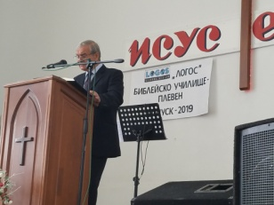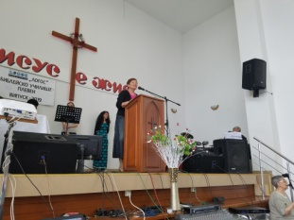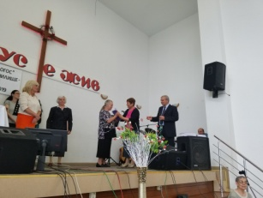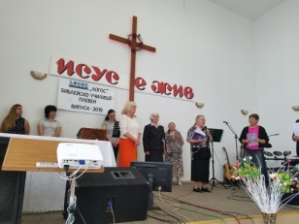

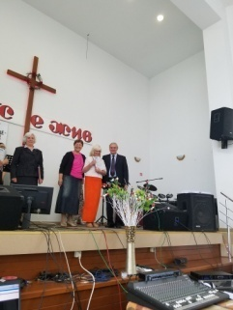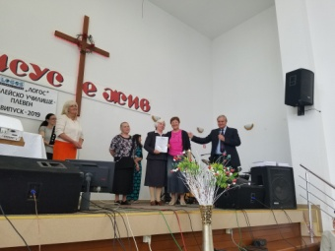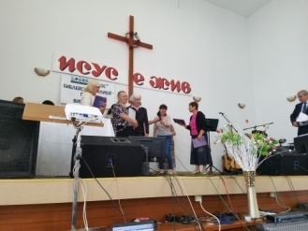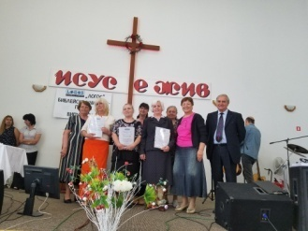

Logos Bible School – Sofia – 23.06.2019
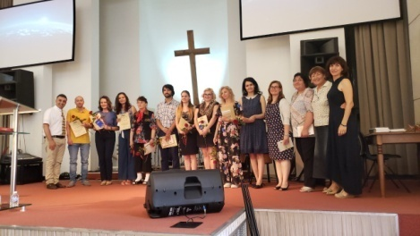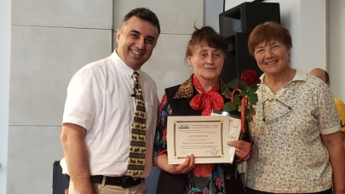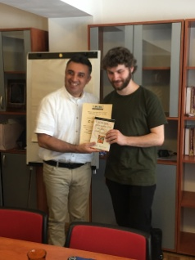

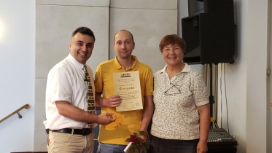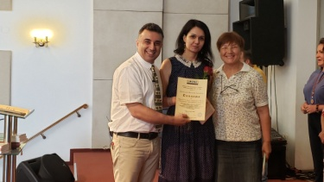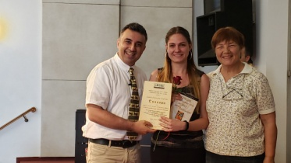

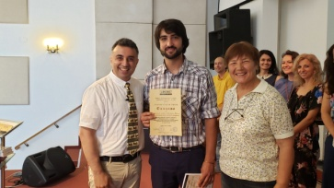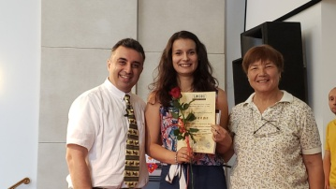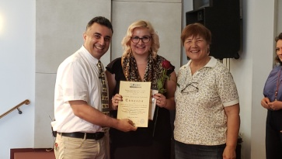

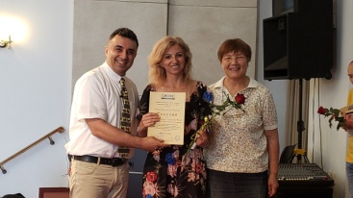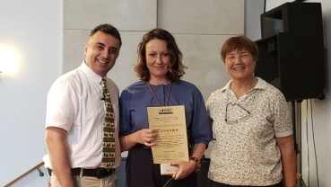

Logos Bible School – Karnobat – 25.06.2019
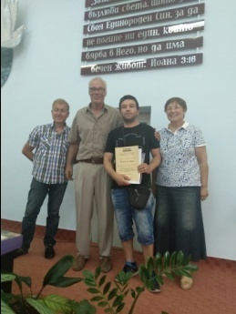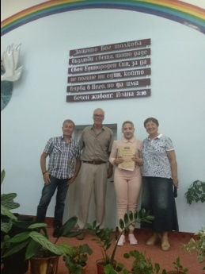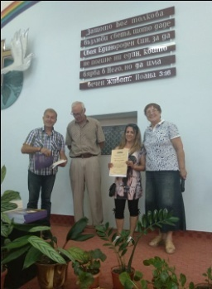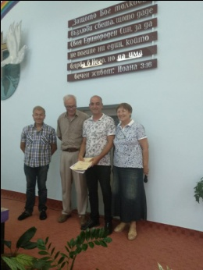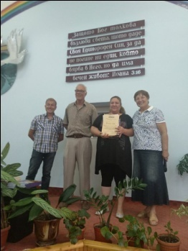

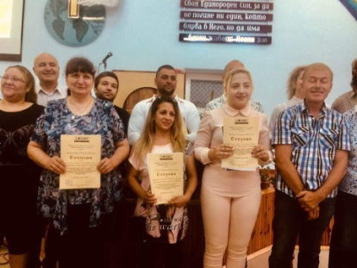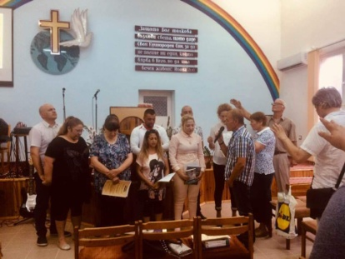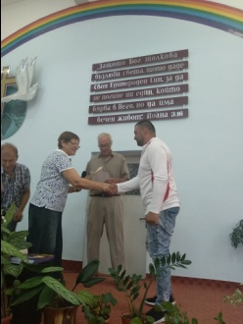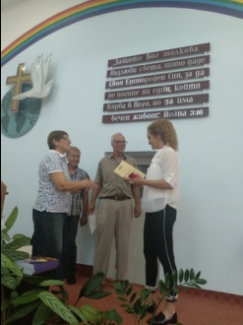

Logos Bible School - Sliven – 7.06.2019
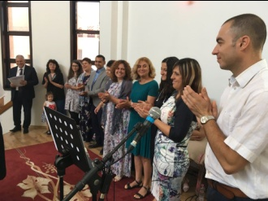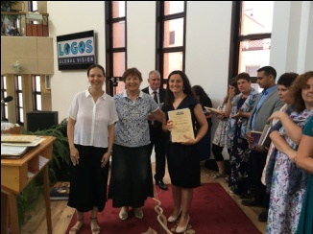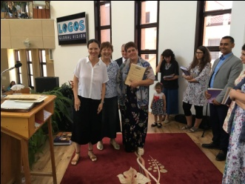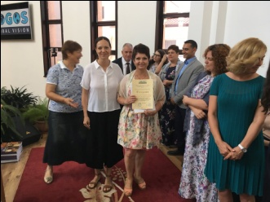

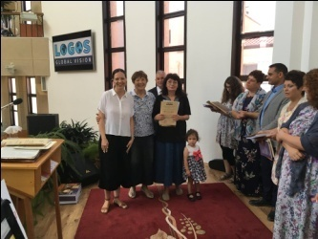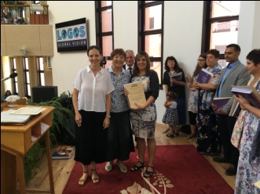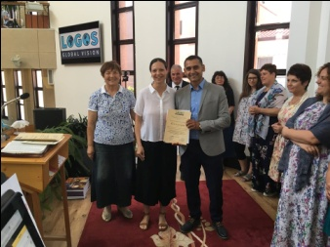

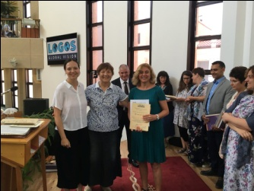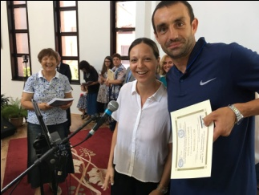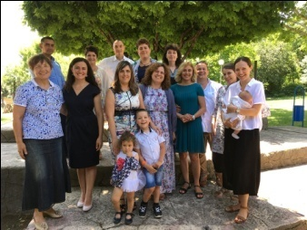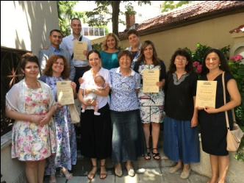

Logos Bible School – Yambol – 14.06.2019
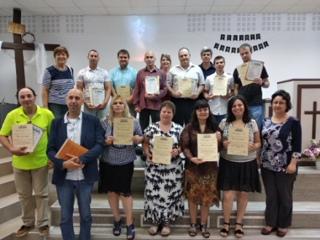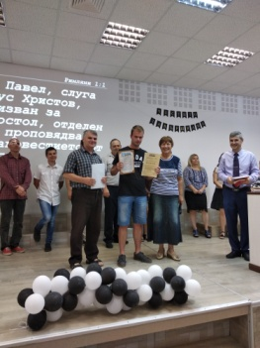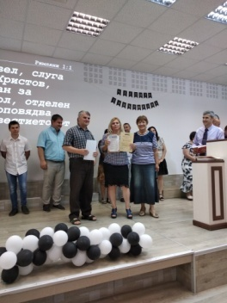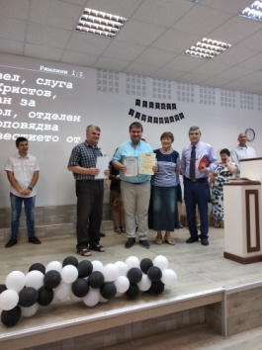

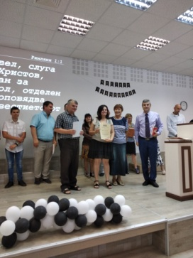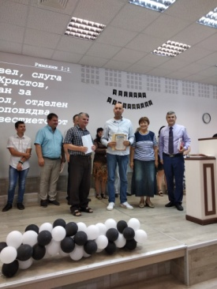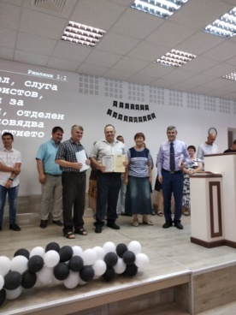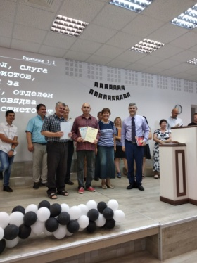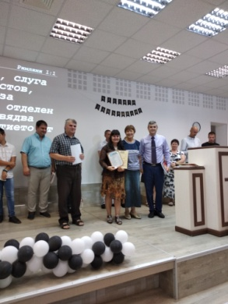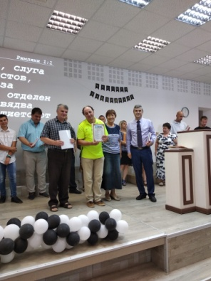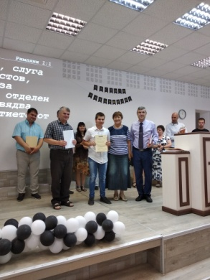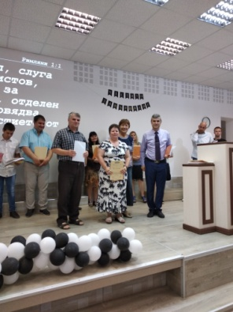
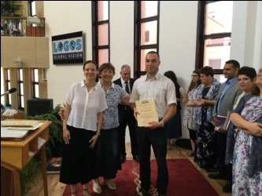

Logos Bible School – Plovdiv – 30.06.2019
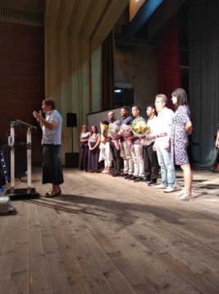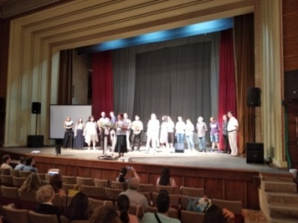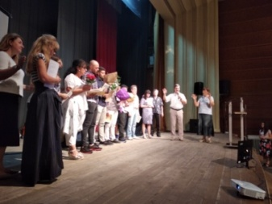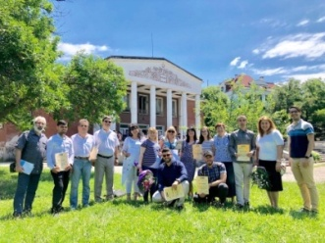

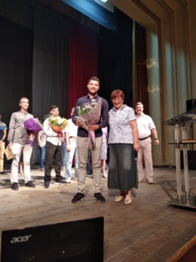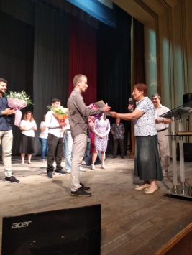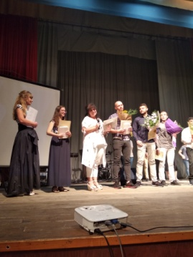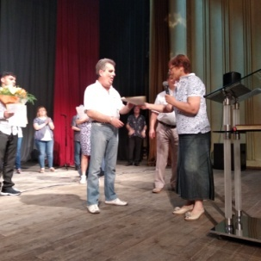

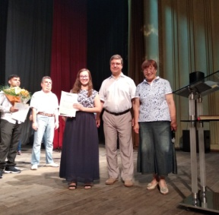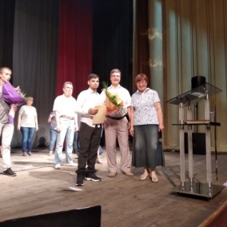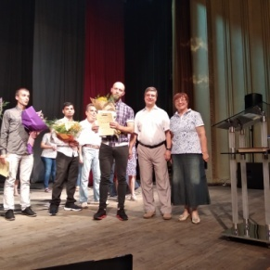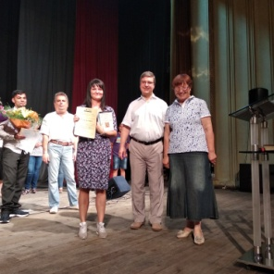

- Kairos course
Logos Bible School in Bulgaria is involved in organizing Kairos courses in Bulgarian churches. Kairos course is part of the training program of Logos Bible school. It is a course for motivating believers and churches for Missions. Kairos courses were done in the cities of Sliven with 14 participants in May and in Sofia with 28 participants. As planned this course continued the expansion of training and motivating believers for missions. Cross cultural experiences were those who none of the participants had before and they were the most interesting experiences durng the training. Here are some testimonies:

Velichko (39) from Sliven: “Kairos is life changing course! I am so impressed by the Biblical worldvew I got from that course. Thank you! I will neve be the same!”

Pastor Tateos (47) from Sofia – I graduated the bible school of Plovdiv when the school was started back in 1992-93. I was a new believer and I was established in God’s word and motivated to serve Him with my life. I have being that since then. I was a Jesus Film Director for 20 years and now I am a pastor of one of the biggest churches in Sofia. I got the vision to make disciples and reach unreached people’s groups in the world. That is why I have a Logos Bible School in our church and Kairos course is part of it now. When I was a student in the bible school I did not take Kairos because it was not existing that time. This year we have it in Logos bible school and I immideatly signed for it together with all students and all teachers. This course will help me readjust my focus and also the focus of our church!’’

Rosen (32) I am teaching at Sofia Logos Bible school which I graduated few years ago. I did not have Kairos course and now I am thankful to take it together with our students and with my wife and my pastor. Thank you so much for helping believers to grow spiritually and get God’s vision for reaching Less Reached people’s groups. It helps us to serve God more effectively. It is wonderful that Kairos course is part of the program of the bible school. I got the big picture of God’s plan and how I can be part of it.”

Kairos in Sliven – May 2019
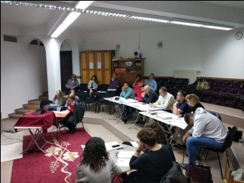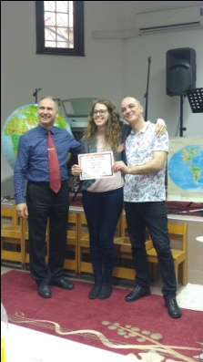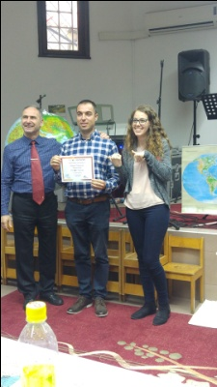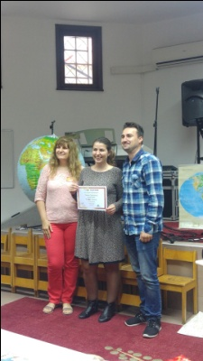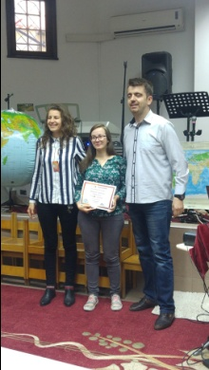

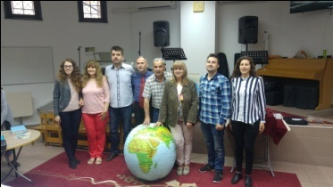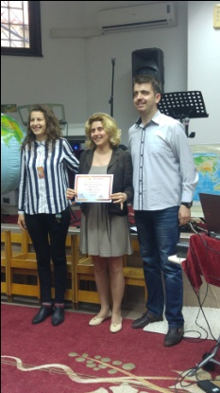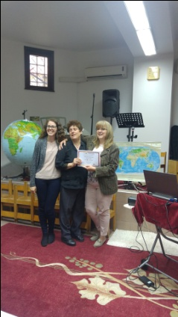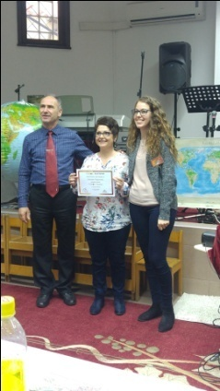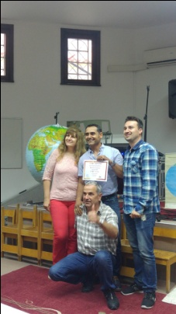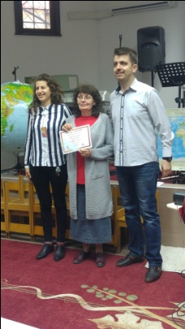

Koiros course in Sofia – June 2019

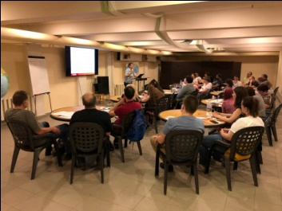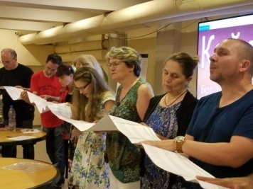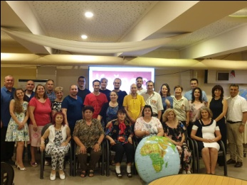

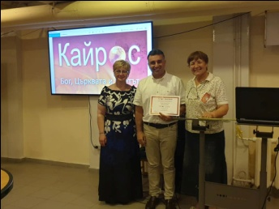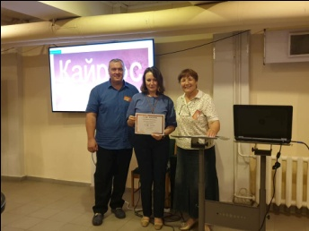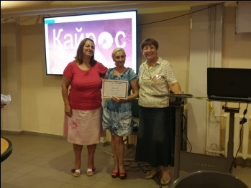

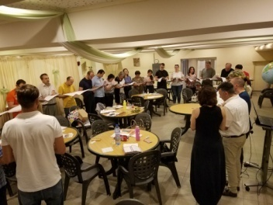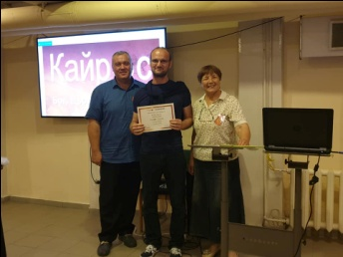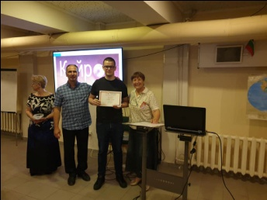

- Human Traffic – Prevention
We continue our work on prevention from Human Traffic. Our main focus is minimizing the number of the victims from Bulgaria sent to Western Europe through Human Traffiking and turning them to modern slaves. Our project “OPEN EYS” was presented 3 times during second quarter of 2019.
Firstly, HT presentstion and brochures were presented and given away to 40 women from the leadership of Bulgarian Evangelical Alliance at their annual meeting in Sofia.

Secondly, it was presented to youth meeting in Gypsy church in Tsalapitsa to a youth meeting with 80 young participants from different places around Tsalapitsa. That was one of the most vulnerable group of Gypcy young people which did not know anything about Human trafficking but often wondered why some girls disappreare and even their families did hot know where they were.

Thirdly, it was presented to young people in the Gypcy church in Saedinenie. We had two different groups for discussion and sharing on the Human Traffiking.
A ppt presentation was presented to all meetings and all participants received a copy of Logos Global Vision brochure on Human Trafficking. There were discussions, Q/A time and many contacts were established with people interested in HT.
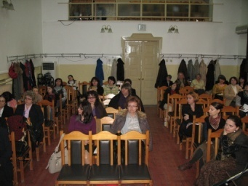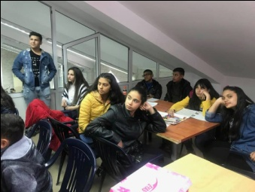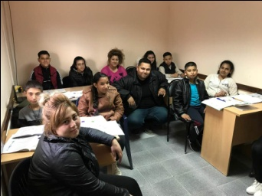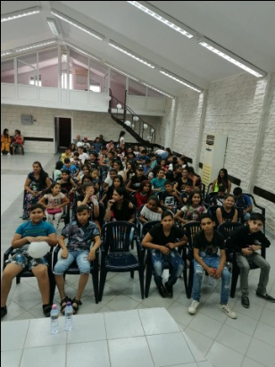
Sofia – women of BEA Saedinenie-young people in two groups Tsalapitsa-80 young people

Future Plans.

- Visiting children in the orphanages in Karlovo, Zelenikovo and Brezovo.
- Summer Bible Study for 40 children in July
- Prevention work on HT for the children in the orphanages and Gipsy communities in Sliven, Perushtitsa, Stolipinovo and distributing brochures, showing films and presentations.
- Please, pray for us to be instruments for fulfilling all those activities for God’s glory and blessing the children, Gipsy children and communities, churches in Bulgaria ! Thank you in advancee.

