LOGOS Global Vision - BULGARIA ACTIVITY REPORT

October - December 2019

Situation in Bulgaria
During the period of October – December 2019 the situation in Bulgaria was intensive because we had local elections on October 27th and new local leaders and City Councels were elected. The activity of Christian Reformation Party was restarted after some years of any activities of that Christian party. Some good and gifted professional Chritian activits were presented as candidates for members of City councels in several big cities of the country. Unfortunately no one was elected due to the lack of understanding the role of Christinas in political parties and authorities among those same Christians. Another problem in the Bulgarian society is still the fight against gender ideology and Child’s strategy between 2020-2030 which is not approved by the Bulgarians. For now Government delayed the decision of that strategy for future time. Similar problems are shaking the familes, children, NGOs and the government. We pray all will be according to Christian values and moral.

- Zelenikovo, Brezovo and Karlovo Orphanages
- During the foth quarter of 2019 our work with children in the four orphanages we regularly visit was very good. We traveled to see them every month, in October, in November and in December. As usual, LOGOS Global Vision volunteers spent two hours with children in each orphanage, as it was allowed for us by the staff there.
In Ocotber we took all 30 children from Karlovo two orphanages to a local park for a picnic with food, prepared from our volunteers and different sports and games. There are five disabled children which were taken on willchairs to the park. They were very happy to be out of the orphanage building, in a park.
In November we took 12 volunteers to Karlovo two orphanages and we gathered the children from both orphanages to one place and we had wonderful time of fellowship with all 30 children, teaching them songs, games, giving them guitar lessons. All children were so excited and so pleased to have time together.

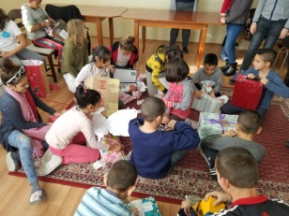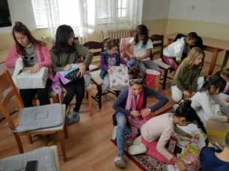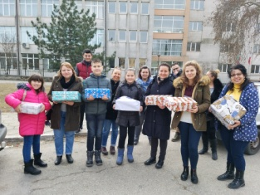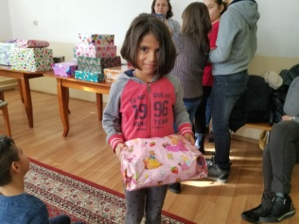

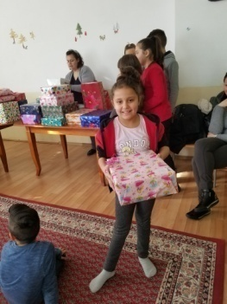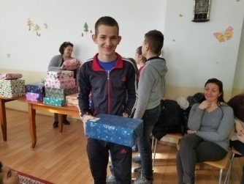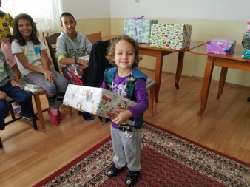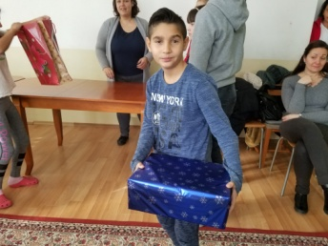

- Helping Bobie after his foot surgery
As you remember from our previous reports, in March 2018 Logos Global Vision Bulgaria helped Bobie from Karlovo orphanage for the surgery of hiss foodAfter that we bought a willchape for his use. Months after that we ordered for Bobie special orthopedic shoes in order to try walking with a help of walker. Several days per week a specialist goes to the orphanage and gives special treatments for helping Bobie start walking and then in the end of Spetember the miracle happened – Bobie can walk by himself on his own feet.
Bobie, the boy with foot surgery is getting better and he can walk by himself most of the time. He is so happy whe he is able to do something for himslef or even help other disabloed chidren in the orphanage.
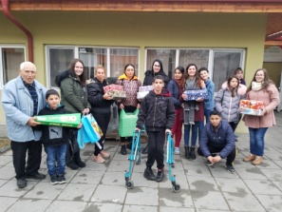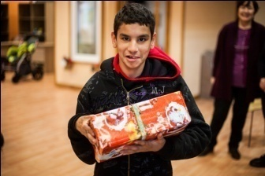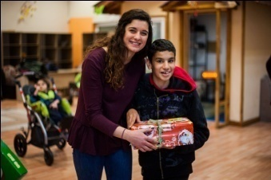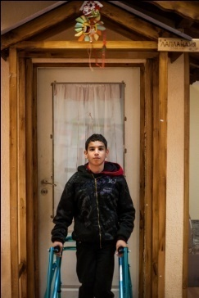

- Refugees in Bulgaria

The number of refugees in Harmanly refugee camp is similar as it was last quarter about 150 refugees who still need our help.
Christmas was time for good works and bringing God’s love to the refugees. Pastor Veseling Yotov organized churches to make 150 Christmas boxes for each person in the camp in Harmanly.
Boxes and bags were distributed to the refugees just before Christmas day. People from Iran., Irak, Syria, Vietnam, Afghanistan and some other places were so happy to receive those special gifts. They were able to hear Christmas songs and short Christmas massage for the biggest and nices gift to all people in all times of the Hystory, Jesus Chrsit!

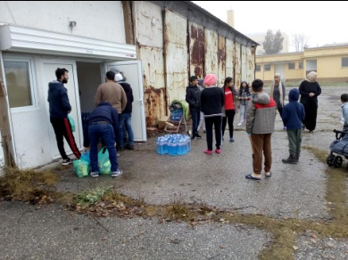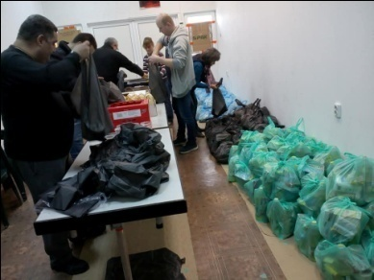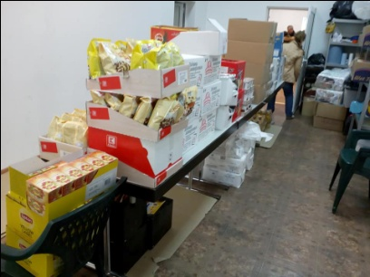
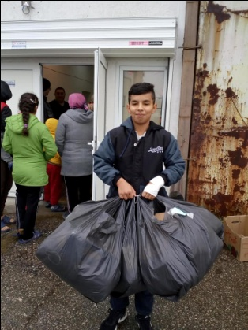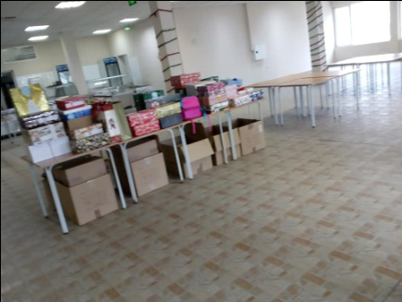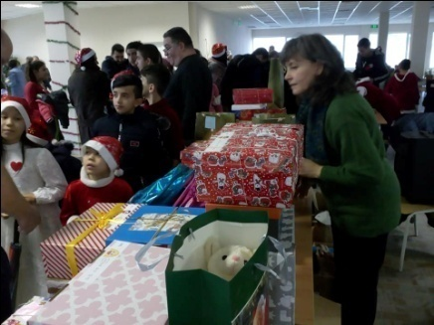

- LOGOS Bible School – 2019 - 2029

Logos Bible School year started in Ocotber with 6 schools as follow:

Plovdiv – 9 students

Perushtitsa – 12 students

Kazanlak – 14 students - fist time school there

Karnobat – 12 students

Yambol 10 students

Pleven – 5 students

------------------------------

Total: 6 schools with 53 students

We started one more school in a Gypsy quarter in Plovdiv, Stolipinovo, with 50 000 Gypsy people living there. In October we had first class in that Gypsy community with 9 students. Unfortunately 7 dropped the classes after one month participating in the cschool. Two students just left and we decided to stop the school because we did not want to waste time of the teachers and finances for the school expenses.

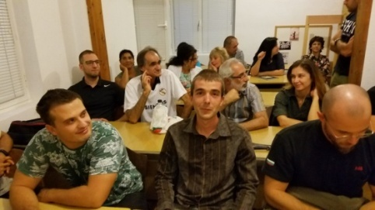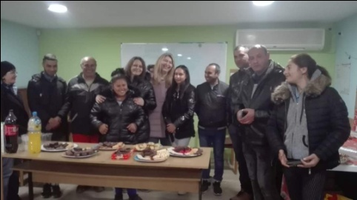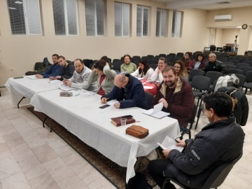

- Kairos course
Logos Bible School in Bulgaria is involved in organizing Kairos courses in Bulgarian churches as partner with PAOB – Pentecostal Assemblies of Bulgaria. We had one course in Sofia in Second Pentecostal church in October 2019. There were 14 participants who were so active in studying about God’s mission to reach all unreached peoples groups for Jesus. In the course they all were so impressed by the practical experiences Kairos course gave them to have.

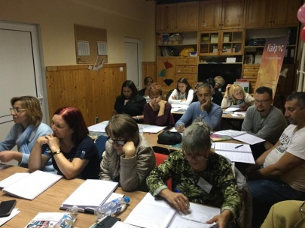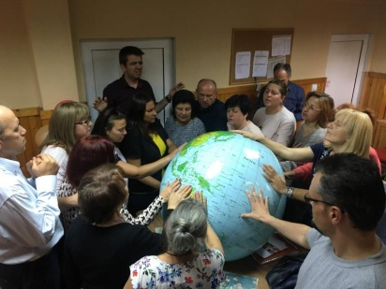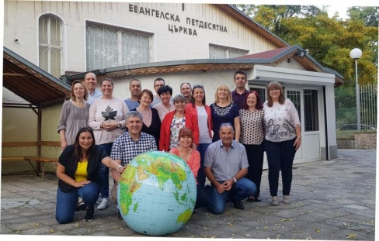

- Human Traffic – Prevention - Seminars on HT in the villages of Yasno Pole and Tsarimir
We continue our work in Human Traffic, so called “modern slavery”. Our main focus is on prevention because it is a great tool for minimizing the number of the victims from Bulgaria sent to Western Europe . The name of the project is “OPEN EYS”. Bulgaria is considered as a sourse of HT victems, boys and girsl, women and men, taken to Eastern Europe to work and exploited in many different ways. One of the most terrible ways is sexual exploitation where thousands of young girls and women and in slavory.
In connection with a similar problem in Bulgaria (British “pastor” who was arrested in England for child abuse and broke English law and left England moving to Sliven, Bulgaria, and started working with Gypsy communities there. After several years living among Gypsy people he was arrested for child abuse in Sliven too. Similar case happened in December 2019 in a village near Balchik, North-West of Bulgaria. A French man (62) was arrested for child abuse – 2 girls age of 9 and 11. Now he is in prison. We see how important is prevention work especially among Gypsy people. Pray for good results of what we are doing.
In October we had a small woman’s meeting in the church of Skutare village with about 30 ladies and girs from Gypcy background. I spoke to them about Human Trafficking, the ways people can be victims, the ways HT victims can go out of that slavory and many other helpful information. I also gave the ladies brochures and the telephone number of hotline if they need help and are willing ot go out of HT situation 0800 20 100. .
The second event is connected with WOW day in Sliven!
WOW DAY in Bulgaria

WOW team from England came to Bulgaria in the end of November and the beginning of December for 5 days. Rachel and Andy David, their daughter Hanna, Lindsey and Sarah! We had wonderful time together visiting different churches and having WOW day/evening in Kalekovets on Thursaday evening, November 30th, and a big WOW day in Sliven on Saturday, December 1th.
In Kalekovets we had evening small WOW day, shorter in time but similar number of ladies participated as WOW day in 2028.Ladies were so happy to see WOW team after one year. The message of Rachel, testimonies of Lindseay and Sarah, the wonderful song of Hanna, touched the hearts and souls of the women. Two special ladies received an acknowledgment for being faithful in difficult situations of their lives. We all had fun and all ladies were blessed.
In Sliven WOW day was done for first time ever. There were about 200 Christian women from different churches and different ethnic background – Bulgarians. Gypsies, Turkish. Rachel shared anointed encouraging message, a testimony from two other English ladies to the women there, songs from Hanna David and prayer to the ladies in Sliven. There was a surprise for the participants – each lady received a small gift from WOW England, a little purple bag full of different lady’s staff and sweets. Rachel also shared about Human Traffic and how dangerous it is for women and girls. She also gave some advice how to prevent being a victim of HT. Maria Todorova, Logos Global Vision - Bulgaria assistant from Sliven was translating to our English guests and also distributed the brochure we printed two years ago through the help of WOW England.
Here is one testimony from Galina Miteva, pastor’s wife in Sliven:
“My name is Galina Miteva, a pastor’s wife from AOG church in the city of Sliven. Our city is known in Bulgaria with very big Gypsy community where the most “prestigious” profession is to be a pimp. Pimps are rich and powerful in the eyes are most of Gypsy people leaving there. The biggest problem in our city is Human trafficking, especially women and girls taken abroad for sexual exploitation. It is a normal for fathers, brothers, cousins to sell their own daughters, sisters, cousins, friends to prostitution. We, as a church in Sliven, have decided to work hard to stop that “dirty” profitable business in our city. We plan starting a prevention work on Human Trafficking in order to decrease the number of girls who are forcefully involved in such a modern slavery. I pray and I hope it will be started soon! Thank you for your help.

- New Project – After school Activities for Gypsy children

The new project for after school work with Gypcy children from public schools started in October in the Gypsy quarter in the village of Tsalapitsa, 16 km west of Plovdiv. Through that project we are helping Gypsy children in Gypsy churches to do better in school and in that way to be easily integrated in Bulgarian society. After classes 19 students from 4th and 5th grade go to church where they get help from high school Gypsy students for preparing their lessons and dong their homework.
In the beginning students and their parents were a little bit reserved even suspicious to our work. They could not understand why we would like to help Gyspy children. Now, three months later things are changed and we have very good relationships and they trust us and believe their children will get better in school and be easily integrated in the society. Students are happy to get help for their lessons and homework and on the top of that to have short bible study with prayer and worship. At the same time they found good friends and safe place instead of wasting their free time hanging around with other children. Parents and children are happy for the new project.
For Christmas all children got Christmas presents – a sport suit for each child – and also we had a Christmas party together.
First semester of the school year will finish in February and then we will compare the grades for the students from last year with this year first semester. We hope for better results!
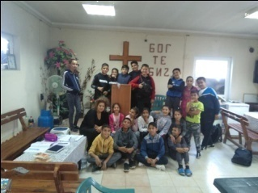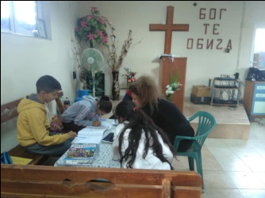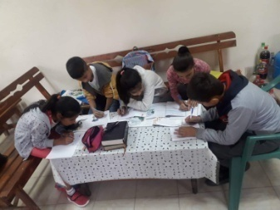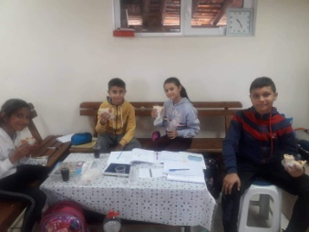
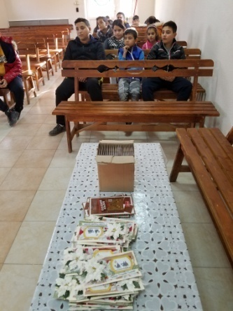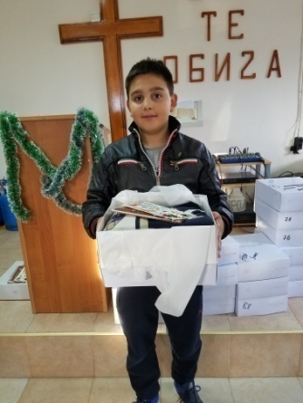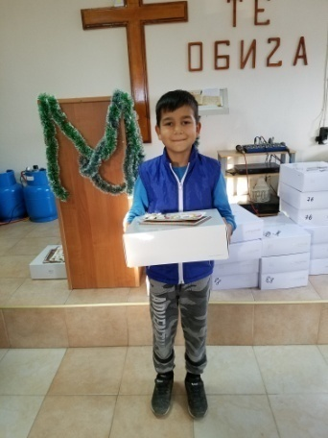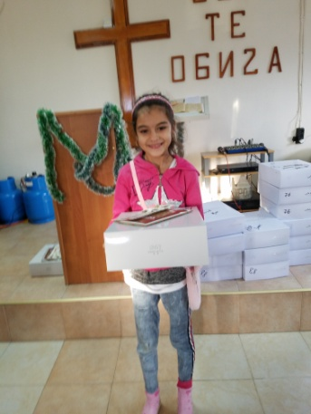
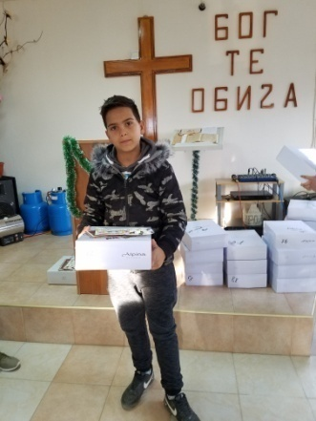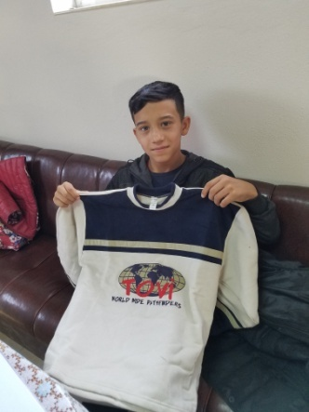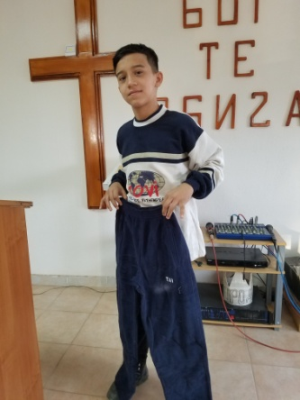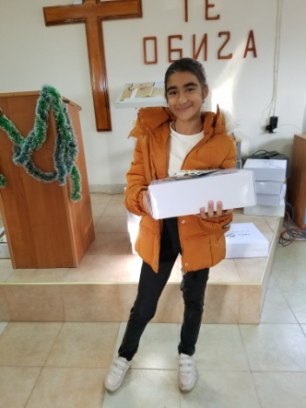

- Christmas 2019
Logos Global Vision – Bulgaria prepared 140 Christmas boxes and distributed them as follow:
70 boxes were given to the children from the four orphanages in Karlovo-2, Zelenikovo and Brezovo
30 boxes to the Gypsy children in the the village of Staro Zelezare, 40 nkm north of Plovdiv
40 boxes were taken to the Gypsy children in Knezha in the poorest area in Bulgaria.
We are thankful to Logos Global Vision – Germany and WOW England for sending extra funds for Christmas boxes in order to bring joy to the children in orphanages and Gypsy churches.

Future Plans.

- Visiting children in the orphanages in Karlovo, Zelenikovo and Brezovo.
- Prevention work in HT for the children in the orphanages and Gipsy communities
- Helping refugees with physical and spiritual help.
- Kairos course in February in Sofia Bible College.
- Helping children from Tsalapitsa After school Project for better results in school and successful integration in the society.
Please, pray for us to be instruments for fulfilling all those activities for God’s glory and blessing the children, refugees, Gipsy children and communities, churches in Bulgaria and Bulgarian n

